DESIGN AND DEVELOP LOW-COST DEVICE FOR MONITORING OCCUPATIONAL NOISE EXPOSURE TOWARD WORKERS IN FACTORY
Mohd Azrin Mohd Said^{1,2}∗, Ahmad Faridzul Japar¹, Nor Kamaliana Khamis², Abdullah Yassin¹, Ana Sakura Zainal Abidin¹, Rudiyanto Philman Jong¹, Mohamad Syazwan Zafwan bin Suffian¹, Aishah Arsad³
¹ Department of Mechanical and Manufacturing Engineering, Faculty of Engineering,
Universiti Malaysia Sarawak, Kota Samarahan, Sarawak, Malaysia
²Department of Mechanical and Manufacturing Engineering, Faculty of Engineering & Built Environment,
Universiti Kebangsaan Malaysia, Bangi, Malaysia
³Institut Tadbiran Awam Negara (INTAN) Kampus Sarawak, Kota Samarahan, Sarawak, Malaysia
∗For correspondence; E-mail: msmazrin@unimas.my or mohdazrin.unimas@gmail.com

ABSTRACT: Occupational noise exposure towards worker is a major problem related to health and safety. It can be annoying and affects the worker’s concentration and health during the working hours. Environmental stress such as occupational noise exposure from factories and industrial sites are well known with a harsh environment. This occupational noise pollution such as heavy machinery noise, high number of large vehicles in and out of the sites which causing undesirable situation as a good working environment. However, the undesired noise exposure also will lead to causes hazard and unhealthy environment at the workplace. Hence, this study done as a solution for this problem where at least decreased the level of problems effect towards workers and increase the company performance. The purpose of this study is to design and develop low-cost device on monitoring occupational noise exposure named (LCDONE). This LCDONE consist of programming for Arduino Wi-Fi UNO based ESPDuino-32 with integrated with IoT analytics platform service ThingSpeak to gathered real time data monitoring. The data collection will be shown in decibel (dB) throughout the ThingSpeak Viewer and has been validated with the established sound level meter RS PRO RS-95 with the average percentage of error for LCDONE from this study is 2.52%. The selected factory for this study and testing LCDONE was in Palm Oil Mill located in Kota Samarahan, Sarawak, Malaysia.
Keywords: Occupational Noise, Noise Exposure, Low-cost device, Workers, Factory, ESP32, ThingSpeak

- INTRODUCTION
Noise is one of a physical hazard that contributes to health issues in the occupational world. One of the major problems is a permanent hearing loss in such heavy industries and manufacturing. Canadian Centre for Occupational Health & Safety show that annoyance, stress, and interference with speech communication are the main concerns in noisy offices, schools, and computer rooms [1]. Therefore, to avoid the negative effect of high level of noise exposure, the amount should be reduced to an acceptable range. One of the best method of noise reduction is to use engineering modifications to the noise source itself, or to the workplace environment [1]. One of the simple engineering control or technology to prevent noise exposure are such as ear plugs and muff, as the technology cannot completely control the problem. Usage of personal protective equipment is one of the methods to reduce perceived noise by the workers.
Some study shows that chronic noise in the workplace caused an increase in blood pressure and heart rate [2]. Heart disease is the leading cause of death for both men and women, according to the Center for Disease Control and Prevention. By ensure the workplace noise level to a minimum it can help increase the health of your workers. Noise-induced hearing loss (NIHL) is the occupational disease most frequently that has been reported to the Norwegian Labor Inspection Authority and the Petroleum Safety Authority [3]. In a working population of 2.7 million, that has been reported that every year the two authorities receive close to 2000 and 600 new reports of NIHL, respectively, accounting for 60 % of all reported work-related diseases [4]. An Excessive noise is a global occupational health hazard with considerable social and physiological impacts, including noise‐induced hearing loss (NIHL) [5].Occupational noise has major exposure in such industries. In heavy industries, research reported noise exposure among workers at steel factories in Indonesia [6-7]; also there are reported on workers’ exposure in Africa [8]; Noise exposure was reported in the textile workers’ exposure in India [9] and in China [10]. Others reported noise exposure among the construction workers in Washington State, USA [11].
In Malaysia, Factories and Machinery (Noise Exposure) Regulation 1989 was promoted conservation program to protect the workers from excessive exposure to noise [12]. By following the regulations from Factories and Machinery (Noise Exposure) Regulation 1989, the permissible exposure limit, the employee or workers shall not be exposed to noise level exceeding equivalent continuous A-weighted sound pressure level of 90 dB(A) or exceeding the limits specified in the First Schedule or exceeding daily dose of unity and must not exposed to noise level exceeding 115 dB(A) at any time [12]. The 85 dB(A) is adopted as a criterion for action (action level). When the action level is reached or exceeded, it necessitates implementation of activities to reduce the risk of noise-induced hearing loss [13]. To date, there has been limited study on noise exposure among workers in Malaysia factory. As the general study indicates some of factory workers tend to not wear hearing protection while performing the work even though being in very close to noisy equipment. The purpose of this study is to design and develop low-cost device that can monitor the noise exposure level among workers and been tested in selected factory at Kota Samarahan, Sarawak, Malaysia.

- METHODOLOGY
To design and develop low-cost devices for noise exposure, there are preliminary study has been done. A set of questionnaires has been developed to gather the perspective of the workers about noise exposure in their workplace. Figure 1 shows the flow chart of this study.

Fig 1: Flow chart of this study

2.1 Questionnaires
Data were collected via anonymous questionnaires. The questionnaires consist of personal details of the workers at the factory and how the level of noise in the workplace affected them. Parts of the questionnaire are taken from an established survey prepared by Indic Society for Education and Development (INSEED) [14]. All of the 40 respondents (workers) from the 2 shifts working hours at the factory are required to answer the questionnaire survey. As for this experimental research, 30 subjects per group is often cited as the minimum [15].
2.2 Levels of noise exposure in the factory
Data regarding the level of noise exposure in the factory were collected during the earlier stage of study by using an available sound level meter. This could be the crucial data for programming of the low-cost device where it becomes benchmark and limit each level of noise boundaries.
2.3 Fabrication of the low-cost device
2.3.1 Conceptual design
The low-cost device consists of three main modules which are sound detector module, ESPDuino (ESP32) Wi-Fi module, and the IoT analytics platform service, which is ThingSpeak software. The block diagram for the design of the smart device is shown in figure 2. The sound detector module functions as input for the data which is the noise of the factory. The microprocessor WiFi UNO based ESP32 then processes the data and display the output in through the cloud receiver IoT analytics platform service to monitoring the noise exposure from the factory. The built-in ESP32 module sends the data from the smart device to the users via cloud. The user received the data and can monitor by using mobile apps or personal computer.
Fig 2: Conceptual design

2.3.2 Programming development
For the programming of the low-cost device, the C language is used as the Arduino UNO is using the Arduino IDE Coding software as its coding platform. Figure 3 shows the flow chart of the low-cost device system. The low-cost device will be programmed and functioned in order as follows:
- A level of noise is detected by the sound detector module sensor gravity analog sound level meter.
- The Wi-Fi UNO Based ESP32 analyze the noise as data following the program coding.
- The data then are sent to the users via IoT cloud through the mobile apps or personal computer.
- The monitoring interface on ThingSpeak IoT analytics then displays the data in dB(A).
- Actions will be taken by the users if necessary.

Fig 3: Programming development

- RESULTS AND DISCUSSION
This study was conducted in selected factory in Kota Samarahan, Sarawak, Malaysia. The selected factory is Palm Oil Mill factory.
3.1 Questionnaire results
From a total of 40 respondents (workers), 36 of them are well known of what noise exposure pollution, while 4 of them do not know. The main sources of the noise at the factory are machinery. Some examples of the machinery provided by the respondents are thresher drum, engine room, machining process, turbine, generator set and boiler. There is a level of noise at the workplace whereby the workers considered it as noise pollution as they (respondents) feel affected by it, based on the questionnaire given. Personal Protective Equipment (PPE) are available and has been provided to the workers by the company, as majority of the respondents stated. Hence, a few others have their own PPE such as earplugs for personal use. The company also has provided safety and health briefing to the staff and workers. Based on the information collected, the briefing is held once a year. The majority of the respondents respond as do not know for this question given. Most of them may have not aware of the company’s briefing on safety and health. Which this may lead the workers to major related safety and health problems.
Figures 4 shows the result the best reasons of why workers not wearing the ear plugs. The sampling method only queried those listed response choices where alternative answers were not allowed. The high responses ranking of difficulty in hearing showed internal consistency by emerging as the best reasons of not wearing attribute with 4.17 mean scores. Interestingly, it exceeded Low enforcement, as well as Difficult to wear, not available, and Do not bother of the availability. From the survey, the majority of them did have disturbance regarding the noise exposure pollution. Headache, loss of sleep, stress and general disturbance are some of the problems facing by the workers.

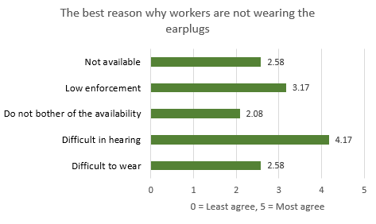
Fig 4: Rankings of attributes of best reason why workers are not wearing the earplugs

From the results also, most of the respondents thought of the importance of having monitoring system at the workplace regarding the level of noise. This shows the present of the low-cost device would have positive impacts on the workers and workplaces.

3.2 Low-Cost Device Development
3.2.1 Morphological Chart
Morphological chart provides a structured approach to concept generation to increase the scope of the search for solutions to a defined design problem. It also can help in generating a complete range of alternative for the product design solutions through systematic analysis of the form the product concern. Figure 5 shows the morphological chart for development of the low-cost device.

Fig 5: Morphological of low-cost device development

As for casing design of the low-cost device, the casing includes a few large rectangle holes on both sides of the casing. All electrical components included the analog sound level meter sensor are fixed on the based on the main body casing. The large rectangle holes can provide maximum collection of noise data in form of wave energy. There are 3 casing design were developed show in figure 6, and casing design 3 was selected as the final design for the smart device’s casing. The large rectangluearholes on both sides of the casing ensures the maximum sound wave to travel to the microphone sensor. The casing was fabricated using 3D printer.

Fig 6: Casing design for low-cost device

3.2.2 Final Product
Detailed design is the phase where the design is refined and plans, specifications and estimates are created. The breakdown of the smart device parts is shown in figure 7 and final product of low-cost device for occupational noise exposure (LCDONE) monitoring in figure 8.

Fig 7: Detail design of low-cost device

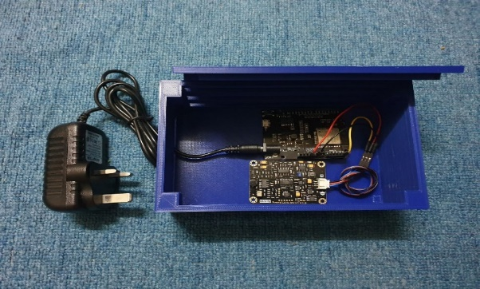
Fig 8: Final product LCDONE

3.3 Low-cost devices (LCDONE) testing and data analysis
Data analyses based on the data recorded. For data collection of the noise level, the device was located at the critical location in the factory. The critical location indicated the location with the highest level of noise which is the nut polishing drum. The device was left to collect data for 7 hours at the same location in factory shown in figure 9.

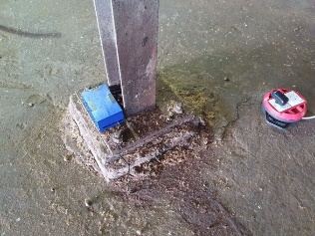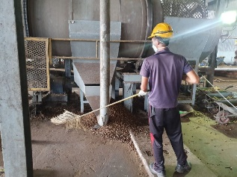
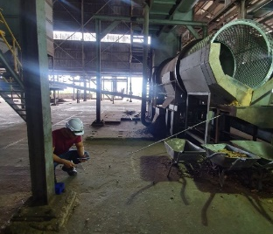
Fig 9: Location of low-cost device at critical location

The data were taken for one working shift which is 7 hours. It showed that the average sound level was at 91.9 dB(A), where each working shift has 7 hours. The data collected are sent to the ThingSpeak IoT analytics platform service software and data displayed as line graph data as shown in figure 10.

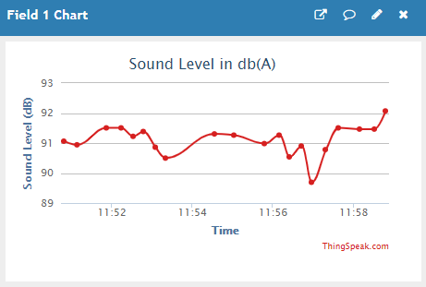
Fig 10: Sound level in dB(A) from ThingSpeak viewer

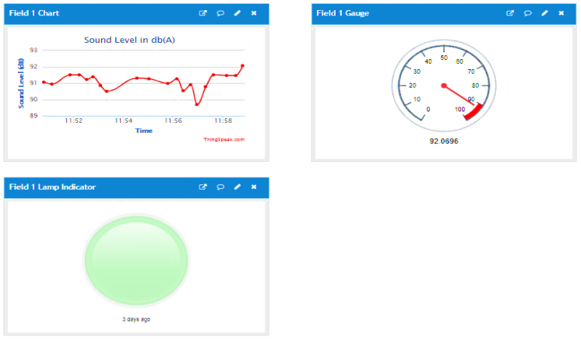
Fig 11: LCDONE Monitoring system
Figure 11 shows the LCDONE monitoring system from ThingSpeak viewer. In monitoring of occupational noise exposure from the ThingSpeak, data collection can be visualized and analyze live data streams in from the cloud. As known that ThingSpeak also is the open IoT platform with MATLAB analytics. The data from here may be used in future analysis with the aid of MATLAB Software. As for this study, the data gathered were visualized only with interface of gauge and lamp indicator for monitoring system.
From the questionnaire result, it was informed that the workers are provided with the earplugs of NRR21. Most of the worker wearing earplugs during working near the nut polishing drum. With the earplugs of NRR21, the decrease in sound level was calculated as (21-7)/2 = 7dB where the equation was provided by 3M (2000). Hence, the new level of noise exposure is at 84.9 dB(A). According to the permissible noise level for OSHA standard [15], the level of sound was at an acceptable level, taking consideration the use of ear plugs by the workers at the factory.

3.3.1 Validation
For data validation, available RS (PRO RS-95) Sound Level Meter has been used. The sound level meter data validation process was done during the data collection as shown in figure 12. This figure 12 shows the differences between develop Low-Cost Device Occupational Noise Exposure (LCDONE) in red line color with (PRO RS-95) Sound Level Meter in green line color.

Fig 12: Comparison data between LCDONE vs PRO RS-95

Figure 12 shows the difference data between the develop LCDONE and establish sound level meter PRO RS-95. This is to validate the data that has been gathered from the low-cost device (LCDONE) can be used in this study. The average error percentage between the LCDONE with PRO RS-95 is 2.52%. It shows that the develop device can be used as one of the low-cost devices in monitoring occupational noise exposure level among workers in the Palm Oil Mill factory as selected factory.

- CONCLUSIONS
This study shows that the importance of noise exposure level among worker can be improved by monitoring from the supervisor or employer. This also can increase human safety in the factory and productivity of the company. The develop low-cost devices for monitoring occupational noise (LCDONE) among work shows can be as a preliminary study to indicate human safety in the workplace especially in Malaysian context. A comprehensive study on others sensor of sound level meter in various factory type such as in textile, metal, manufacturing industry and others related factory would be needed to verify the initial results obtained in this study.
ACKNOWLEDGMENTS
The authors acknowledge the financial support from Osaka Gas Foundation in Cultural Exchange (OGFICE) Research Grant from Japan (IG/F02/OSAKA/02/2018), Many thanks to all the colleagues, undergraduate students from Universiti Malaysia Sarawak (UNIMAS) for their assistance and involve in this research project and to Universiti Kebangsaan Malaysia (UKM) Research Grant (GUP-2019-019).

REFERENCES
[1] Canadian Centre for Occupational Health & Safety (2018). Noise Physical Hazard in Workplace. Retrieved from website on 14 October 2020. https://www.ccohs.ca/topics/hazards/physical/noise/
[2] Jeremy Trotman. How a Noisy Workplace Affects Health (2015). JTA Health, Safety & Noise Specialist. Retrieved from website on 14 October 2020. https://jta.com.au/blog/how-noisy-workplace-affects-health
[3] Arve Lie, Marit Skogstad, Håkon A. Johannessen, Tore Tynes, Ingrid Sivesind Mehlum, Karl‑Christian Nordby, Bo Engdahl, Kristian Tambs. Occupational noise exposure and hearing: a systematic review. Int Arch Occup Environ Health (2016) 89:351–372. DOI 10.1007/s00420-015-1083-5
[4] Samant Y, Parker D, Wergeland E, Wannag A (2008) The Norwegian labour inspectorate’s registry for work-related diseases: data from 2006. Int J Occup Environ Health (2006) 14(4):272–279.
[5] Nelson, D.I., Nelson, R.Y., Concha‐Barrientos, M. and Fingerhut, M. (2005), The global burden of occupational noise‐induced hearing loss. Am. J. Ind. Med., 48: 446-458. doi:10.1002/ajim.20223
[6] Harmadji S, Kabullah H. Noise induced hearing loss in steel factory workers. Folia Medica Indon 2004;40: 171-174.
[7] Boeteng CA, Nikrumah K, Amedofu GW. Industrial noise pollution and its effects on hearing capabilities of the workers: A study from sawmills, printing presses and corn mills. African J Health Sci 2004; 1:55-60.
[8] Omokhodion FO, Adeosun AA, Fajola AA. Hearing impairment among mill workers in small scale enterprises in southwest Nigeria. Noise Health 2007; 9:75-77
[9] Bedi R. Evaluation of occupational environment in two textile plants in Northern India with specific reference to noise. Ind Health 2005; 44:112-116.
[10] Lu J, Cheng X, Li Y, Zeng L, Zhao Y. Evaluation of individual susceptibility to noise-induced hearing loss in textile workers in China. Arch Environ Occup Health 2005;60: 287-94.
[11] Neitzel RL, Stover B, Seixas NH. Longitudinal assessment of noise exposure in a cohort of construction workers. Ann Occ Hyg 2011;55(8):906-916.
[12] Government of Malaysia 1989. Laws of Malaysia Factories and Machinery Act 1967 (Act 139) P.P.(A) 1/89 (English)
[13] Tengku Hanidza T.I., Amirah A M Jan, Ramdzani Abdullah, and Madinah Ariff. A Preliminary Study of Noise Exposure among Grass Cutting Workers in Malaysia. Procedia - Social and Behavioral Sciences 91 (2013) 661 – 672.
[14] Indic Society for Education and Development (INSEED). Retrieved from http://www.inseed.org/. Survey title: “Noise Pollution: A health hazard?”
[15] Gay, L.R. & Diehl, P.L. (1992). Research Methods for Business and Management. New York: Macmillan.
[16] Occupational Safety and Health Administration. (OSHA) Occupational Noise Exposure 1910.95. Retrieved from website on 14 October 2020. https://www.osha.gov/laws-regs/regulations/standardnumber/1910/1910.95.

∗For correspondence; E-mail: msmazrin@unimas.my or mohdazrin.unimas@gmail.com

