IMPROVING DIFFERENT PARAMETERS OF TRANSFORMER OIL FROM PAKISTAN NATIONAL REFINERY LIMITED
¹Syed Wajid Hussain, ^{1*}Amtul Qayoom, ² Syed Tariq Ali, and ¹Ghazanfar Hussain
¹Departmen of Chemistry, NED University of Engineering and Technology, Karachi, Pakistan
²Department of Chemistry, University of Karachi, Karachi, Pakistan
Corresponding author: amtulq@neduet.edu.com
ABSTRACT: The aim of this study is to improve the quality of selected Group I base oil by chemical treatment and study the impact of treatment on their various parameters. Hence, the different samples of base oil I were treated with concentrated sulphuric acid to remove moisture and easily oxidizable compounds followed by bleaching with earth clay. Selected electrical, chemical and physical properties were measured before and after acid/clay treatment. Initial tests indicated that the use of acid and earth clay treatment of the Group I base oil improved dielectric dissipation factor, water content, total acidity and color. These properties are the basic requirement of good transformer base oil, which normally belongs to Group II base oil. Therefore, we select Group II base oil; LP-70 (imported) as a reference and Group I base oil 65 NHVI for optimization of the method. Thus acid/clay was found to be a good treatment for base I transformer oil.
Keywords Transformer oil; Acid treatment and Characterization; Bleaching earth clay

1. INTRODUCTION
Insulating oil in an electrical power transformer is commonly known as transformer oil. It is normally obtained by fractional distillation and subsequent treatment of crude petroleum[1]. That is why this oil is also known as mineral insulating oil. Transformer oil serves following purposes:
- It dissipates heat of the transformer i.e. acts as coolant [2].
- It helps to preserve the core and winding as these are fully immersed inside oil.
- It prevents direct contact of atmospheric oxygen with cellulose made paper insulation of windings, which is susceptible to oxidation [2].
Group I base oils contain less than 90 percent saturates, greater than 0.03 percent sulfur and with a viscosity-index range of 80 to 120 [3]. Group I base oils are solvent refined, which is a simpler refining process. That is why they are the cheapest base oils in the market. Group II base oils are hydrotreated and contain more than 90 percent saturates, less than 0.03 percent sulfur and with a viscosity index of 80 to 120 [3]. Group II base oils have better anti-oxidation properties. They also have a clearer color. Group II base oils are imported and cost more in comparison to Group I base oils.
The procedure for the purification of oil consists of filtration of the oil before subjecting to treatment using acid/clay, distillation/clay, and acid treatment with activated charcoal treatment methods [4]. Many studies have reported that bleaching of oil using acid activated clays is a successful treatment method [4 – 7].
In acid treatment process, oil is treated with sulfuric acid to remove aromatics and other non-hydrocarbons, followed by treatment with clay to neutralize and improve appearance, color and color stability by removing colored and colorless pigments and also improve oxidation stability of the final oil products [8-10].The acid sludge at the bottom formed from the acid treatment of oil is a black or dark brown in color and containing some harmful sulfonic acid and some impurities [11,12].
Clay treatment process is carried out to remove acidic impurities and to neutralize acidic oil. Acid clay is then removed using filters. The finished oil is neutral in acidity, non-corrosive and good electrical parameters [8].
The present study involves acid /clay treatment on base II oil to improve its physical and chemical properties and compare various quality parameters of treated oil with base II oil.

2. MATERIALS AND METHODOLOGY
Standard test methods IEC-60296 of testing and characterization of transformer oil were used as recommended by IEC (International Electrotechnical Commission) [13].

2.1 Reagents and raw materials used
Imported Group II base Oil (LP-70), Locally Group I base Oil (65NHVI also known as Spindle oil, Pakistan national refinery limited), Sulphuric acid, Bleaching earth clay (Bleaching earth clay also known as Bentonite clay, Tahir Asad Industries (Pvt.) Ltd).

2.2 Instruments used
Color Comparator (Fisher Color Comparator, AF 650), Karl fisher (Karl Fischer KF-875), DDF tester (Baur oil tester DTL C) and Potentiometer titration (Metrohm SM Titrino-702).
2.3. Acid/Clay Treatment
In this study various combinations of earth clay and sulphuric acid dosage were made for the treatment optimization (Table 2.1). The 500 ml of Group I base oil was used for each combination. The Group I base oil was firs treated with sulphuric acid with constant stirring for 3 minutes at ambient temperature then allowed to settle for four hours. The clear supernatant oil was separated by separating funnel and acidic residues were discarded. The supernatant oil was then treated with different dosages (v/wt.%) of bleaching earth with continuous stirring of the mixture for eight minutes at ambient temperature. Bleaching earth treated oil was then allowed to settle for four hours. Supernatant was decanted and residues were discarded. The treated oil was finally filtered using a filter paper by Buchner funnel. Color, water content, dielectric dissipation factor and total acid number (TAN) were recorded for all combinations.
TABLE 2.1 Symbols codes of Group I base oil (Spindle Oil) after and before Acid/Clay treatment and Group II base oil (Imported Oil)
Oil Specimen | Symbol Code
LP-70 Imported Group II Oil | G II
65 NHVI Spindle Oil | GI
Spindle Oil acid/clay treatment method with0.05 % sulfuric acid and 0.05% clay | A
Spindle Oil acid/clay treatment method with0.05 % sulfuric acid and 0.3% clay | B
Spindle Oil acid/clay treatment method with0.1 % sulfuric acid and 0.1% clay | C
Spindle Oil acid/clay treatment method with0.1 % sulfuric acid and 0.35% clay | D
Spindle Oil acid/clay treatment method with0.3 % sulfuric acid and 0.3% clay | E
Spindle Oil acid/clay treatment method with0.3 % sulfuric acid and 0.55% clay | F
Spindle Oil acid/clay treatment method with0.5 % sulfuric acid and 0.5% clay | G
Spindle Oil acid/clay treatment method with0.5 % sulfuric acid and 0.75% clay | H
Spindle Oil acid/clay treatment method with0.5 % sulfuric acid and 1.0% clay | I
Spindle Oil acid/clay treatment method with0.5 % sulfuric acid and 1.25%clay | J
Spindle Oil acid/clay treatment method with0.5 % sulfuric acid and 1.5% clay | K
Spindle Oil acid/clay treatment method with0.5 % sulfuric acid and 1.75% clay | L
Spindle Oil acid/clay treatment method with0.5 % sulfuric acid and 2.0% clay | M
Spindle Oil acid/clay treatment method with0.5 % sulfuric acid and 2.25% clay | N
Spindle Oil acid/clay treatment method with0.5 % sulfuric acid and 2.50% clay | O

2.4 General characteristics of transformer oils
For transformer base oils the most important properties are color [14], water content [15], dielectric dissipation factor (DDF) [16] and total acid number (TAN) [17]. The limits of these parameters for transformer base oil are shown in Table 2.2.
TABLE 2.2 Characteristics of Transformer Oil
Characteristics | Requirements | Method of test
Color | Max. 0.5 (as per Pakistan Requirement) | ASTM D-1500
Water content | Max. 30 (ppm) | IEC-60184
Di electric dissipation factor | Max. 0.005 | IEC-60247
Acidity (TAN) | Max. 0.01 mg KOH/g | IEC-62021-1

3. RESULT AND DISCUSSION

3.1 Experimental Results
All observed data and results for the electrical, physical and chemical properties is summarized in Table 3.1 and data is also presented in trend plots for comparing the dielectric dissipation factor (tan δ), color, water content and acidity characteristics between Group I base oil (locally) and Group II base oil (Imported).

TABLE 3.1 Electrical, chemical and physical properties Group I base oil (Spindle Oil) after and before Acid/Clay treatment and compare with Group II base oil (Imported Oil)

Method | ASTM D-1500 | IEC 60184 | IEC 60247 | IEC 62021-1
Parameters  Specimen | Color | Water Content (ppm) | Dielectric Dissipation Factor | Acidity  (mg KOH/g)
GI | 0.0 | 27.6 | 0.0025 | 0.0089
GII | 0.5 | 108.5 | 0.0142 | 0.0753
A | 0.5 | 104.5 | 0.0140 | 0.1018
B | 0.5 | 102.9 | 0.0133 | 0.0933
C | 0.5 | 103.3 | 0.0139 | 0.1107
D | 0.5 | 101.8 | 0.0130 | 0.0832
E | 0.5 | 102.1 | 0.0130 | 0.1156
F | 0.5 | 100.3 | 0.0125 | 0.0891
G | L 0.5 | 75.6 | 0.0110 | 0.1210
H | L 0.5 | 72.3 | 0.0106 | 0.0741
I | L 0.5 | 69.7 | 0.0096 | 0.0530
J | L 0.5 | 65.0 | 0.0072 | 0.0322
K | L 0.5 | 62.1 | 0.0065 | 0.0138
L | L 0.5 | 40.8 | 0.0032 | 0.0096
M | L 0.5 | 27.3 | 0.0024 | 0.0085
N | L 0.5 | 26.8 | 0.0022 | 0.0079
O | L 0.5 | 26.5 | 0.0020 | 0.0075

3.2 PROPERTIES
The main oil properties are divided to the physical, chemical and electrical characteristics [18].

3.2.1 PHYSICAL PROPERTIES

Color
The color and appearance of transformer oil are useful for comparative evaluation. Cloudiness or sediment indicates free water, insoluble sludge or dirt particles. Darkening or dark oil is a sign of oil ageing. The analyzed oil color is assigned a number ranging from 0 to 8, whereby the level of discoloration is indicated by means of the rising color number. Good oils have–WHITE or PALE YELLOW color, Bad oils have AMBER color, very bad oils have- BROWN color and oil in disastrous condition –BLACK color [19]. For good quality transformer base oil, color should not more than 0.5 on a colorimeter scale according to ASTM D-1500 [14]. It has been observed that after acid/clay treatment process on each combination, color improved from 0.5 to L 0.5.While the color of Group II base oil (Imported) is 0.0 (Colorless). Figure 3.1 shows the color comparison of Group I base oil before and after (acid/clay treatment) and Group II base oil in this research work.
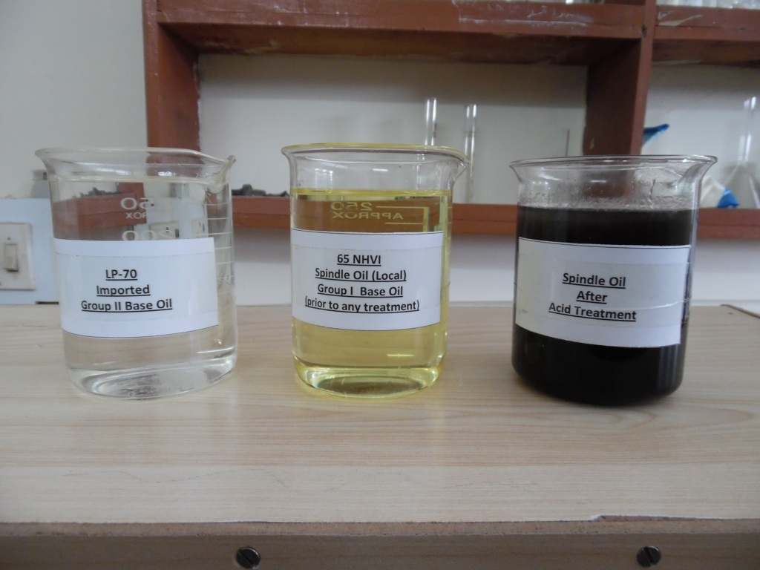

Figure 3.1. Color comparison of Group II base oil (Imported), Group I base oil (Local) and Group I base oil (after acid treatment)

Water Content
Mineral insulating oil has low compatibility for water, i.e. one drop of water at room temperature is good enough to saturate one litre of new insulating oil [20]. Water content can reduce the insulating properties of the oil, which may result in dielectric breakdown. This is of particular importance with fluctuating temperatures because as the transformer cools down, any dissolved water will become free, resulting in poor insulating power and fluid degradation. Many transformers contain cellulose based paper used as insulation in the windings. Water degrades this cellulosic paper. The water in the oil allows dissolved oxygen to act on the oil and causes oxidation and reduce the dielectric constant. According to IEC 60184 [15], for a good quality transformer base oil, the moisture content should not be more than 30 ppm. It has been observed that the moisture content decreased with the increase of clay percentage treatment from 108.15 ppm to 26.5 ppm. While the moisture content of Group II base oil (Imported) was found to be 27.6 ppm. Therefore, in the view of result it can be concluded that the optimum value of clay for moisture control is lying between 2.0 to 2.25% (v/wt.).

Graph 3.1. Water content (ppm) of Group I base oil (Spindle Oil) before and after Acid/Clay Treatment and Group II base oil (Imported Oil).
3.2.2. ELECTRICAL PROPERTIES

Dielectric Dissipation factor (DDF)
Dielectric dissipation factor is also known as loss factor or tan delta of transformer oil. It is a diagnostic method of dielectrics to determine the quality of insulation[21]. Higher value for the loss angle indicates a high deg-ree of contamination. Hence it is desirable to have loss angle(tanδ) as small as possible. According to IEC 60247 DDF @ 90 ranged not more than 0.005 [16]. It has been noticed that, the DDF @ 900 improved after acid /clay treatment process of Group I base oil from 0.0142 to 0.0024. While the DDF @ 90 of Group II base oil (Imported) is 0.0025. It can be concluded that the optimum value of clay for DDF control is lying between 2.0 to 2.25% (v/wt.).

Graph 3.2. Dielectric Dissipation Factor of Group I base oil (Spindle Oil) before and after Acid/Clay Treatment and Group II base oil (Imported Oil).

3.2.3. CHEMICAL PROPERTIES

Total Acid Number
Total acidity also called total acid number (TAN) refers as a guide in the quality control of oil and also as a measure of transformer oil degradation [22]. Acidity increases the oxidation process in the transformer oil. Acid presence also accelerates rusting of iro in combination with moisture.
According to IEC -62021-1 total acid number should not be more than 0.01 mg KOH/g [17]. It has been observed that, the total acid number improved after acid /clay treatment process of Group I base oil from 0.075 to 0.0075. While the total acidity of Group II base oil (Imported) is 0.0089. It can be concluded that the optimum value of clay for TAN is lying between 2.0 to 2.25% (v/wt.).

Graph 3.3. Total Acid Number (mg KOH/g) of Group I base oil (Spindle Oil) before and after Acid/Clay Treatment and Group II base oil (Imported Oil).

CONCLUSION
Attempt has been made to improve properties such as electrical, physical and chemical of transformer oil by acid/clay treatment. Various ratios of sulphuric acid and clay were tested for treatment optimization and best results were obtained using 0.5 % sulfuric acid and 2.0% clay. Further, increase in dosage had only a little effect on performance. At optimized acid/clay dosage moisture content reduced from 108.5 ppm to 27.3 ppm, Dielectric dissipation factor decreased from 0.014 to 0.0024 while TAN reduced from 0.0753 to 0.0085 mg KOH/g.
In the light of above results we can conclude that the Group I base oil can be converted into the Group II base oil by acid/clay treatment.

REFERENCES
[1] Goedde, G. L., Gauger, G. A., Lapp, J. and Yerges, A. P. “Dielectric fluid having defined chemical composition for use in electrical apparatus,” Google Patents, (1997).
[2] Rouse, T. O., "Mineral insulating oil in transformers," Electrical Insulation Magazine, IEEE, 14(3):6-16(1998)
[3] Pedišić, L., Petran, J., Munić, J. and Polenus, I. "Possibility of Biodegradable Base Oils Application in Neat Metal working Oils," 48(3), 193-228 (2009).
[4] Udonne, J. D., "A comparative study of recycling of used lubrication Oils using distillation , acid and activated charcoal with clay methods," Journal of Petroleum and Gas Engineering, 2(2): 12–19(2011).
[5] Usman, M. A., Oribayo, O., and Adebayo, A. "Bleaching of Palm oil by Activated Local Bentonite and Kaolin Clay from Afashio , Edo-Nigeria,":10:1-2(2008).
[6] Makhoukhi, B., Didi, M. A., Villemin, D., and Azzouz, A. "Acid activation of Bentonite for use as a vegetable oil bleaching agent" Grasas Y Aceites, 60(4): 343–349(2009).
[7] F.V. Diaz and S. P. de S. "Studies on the acid activation of Brazilian semiotic clays" Nova, 3(24): 345–353(2001).
[8] Speight, J., Douglas I. E. "Refining Used lubricating oil." CRC Press: 99 (2014)
[9] Didi M.A., Makhoukhi B., Azzouz A., and Villemin D, "Colza oil bleaching through optimized acid activation of bentonite. A Comparative Study," Applied Clay Scienc: 42, 336–344 (2009).
[10] Farihahusnah, H., Mohamed K. A and Wan M. A. W. D. "Textural characteristics, surface chemistry and activation of bleaching earth" A Review, Chem. Eng. Journal, 170:90–106 (2011).
[11] ETERIGHO, E. J., and OLUTOYE, M. A. "Quality Improvement of an Acid Treated Fuel oil." Leonardo Electronic Journal of Practices and Technologies, 7(12), 95–104 (2008).
[12] Lipscomb. T.G. "II. Mineral Insulating Oil Manufacturing and Safekeeping. Electrical Insulating Oils." American Society for Testing and Material, Philadelphia. (1998).
[13] Nasrat, L., Abdelwahab, M., & Ismail, G. "Improvement of Used Transformer Oils with Activated Bentonite,": 588–593 (2011).
[14] Products, P., & Petrolatum, "I. Standard Test Method for ASTM Color of Petroleum Products (ASTM Color Scale) 1." Annual Book of ASTM Standards: 1–5(1959).
[15] 60184 IEC, “Insulating liquids–Determination of water by Coulometric Karl Fisher titration – Test method,” Int. Electrotech. Comm.: (2008)
[16] 60247 IEC, “Insulating liquids – Determination of the dielectric dissipation factor – Test method,” Int. Electrotech. Comm.: (2004)
[17] IEC 62021-1, “Determination of Acidity-Part-1 Automatic potentiometric titration – Test method,” Int. Electrotech. Comm., (2003)
[18] Mohammad, R. Meshkatoddini Shahid Abbaspour S. "Aging Study and Lifetime Estimation of Transformer Mineral Oil Power and Water University of Technology , Tehran , Iran" Carbon, 1(4):384–388(2008).
[19] Chowdary, M. L., Singh, S. K., Jarial, R. K. "Analysis of Oil Quality Index and Dielectric Dissipation Factor,":4(4):223–230 (2014).
[20] Shukla, P., Sood, Y.R., R. K. J. (n.d.). "Experimental Evaluation of Water Content In Transformer Oil" International Journal of Innovative Research in Science, Engineering and Technology, 2(1): 2013
[21] Onal, E. "A Study for Examining Dissipation Factors of Various Insulations and Test Transformers in the Wide Range of Frequency", 5(5): (2012).
[22] Emam, E. A., a Shoaib, A. M. "Re-refining of Used Lube Oil , II- by Solvent / Clay and Acid / Clay-Percolation Processes," 2(11): 1034–1041 (2012).

