GEOMETRICAL COMPARISON OF MICROSTRIP PATCH ANTENNA ARRAY FOR GAIN AND DIRECTIVITY ENHANCEMENT
Ahlam Jameel¹, Suhail Aftab Qureshi², Fahim Gohar Awan², Akrama Khan³, ⁴Khadim Hassan Shirazi Kamran Ezdi⁴
¹Lahore College for Women University, Lahore Pakistan, ²Department of Electrical Engineering, UET, Lahore, Pakistan, ³University of Capetown, South Africa, ⁴University of Central Punjab.
Contact: ahlam.khan@hotmail.com, fahimgohar@hotmail.com
ABSTRACT — Microstrip antennas can be employed as a single patch or an array. A microstrip patch antenna consists of a feeding mechanism and a patch itself which acts as a radiating element. Its design mainly depends on tweaking techniques through which the patch antenna could give better directivity, gain and radiation pattern. In this paper a comparison between the design techniques and modeling of its geometrical shapes (rectangular and triangular patches) as well as arrays is discussed. The effect on antenna parameters such as gain, directivity and return loss is analyzed by increasing the number of patches in linear fashion at 2.4 GHz frequency and an optimal solution is proposed. Inset feeding technique is implemented and the results are analyzed with the help of computer simulation tool (CST) studio.

Index Terms — Microstrip patch antenna (MPA), antenna array, inset feeding.

- INTRODUCTION
Antennas come in various shapes and sizes. These consist of a single patch or combination of patches, usually called arrays. Each of them is specifically designed for a particular application and frequency range. For instance, radars are used for long distance high power applications whereas microstrip patch antennas (MPAs) are used for low power applications. The possibilities are endless, from interplanetary communication to near field communication (NFC) and with that antennas have helped us reach this so called information age we are living in.
Michael Faraday was the first to question this mysterious phenomenon and the research has continued ever since. MPAs have been of great interest to the engineers because of their continuously evolving characteristics like easier interfacing with electrical circuits, ease of manufacturing, low fabrication costs and light weight structure. With all these advantages MPAs have certain limitations as well, such as low gain, low directivity, low bandwidth and low efficiency which degrade their performance [1], [2]. Many researchers are working to enhance these parameters using different techniques. Most common method used to enhance gain and directivity is with the aid of reflector planes. In [3] a second flame retardant layer (FR-4) coated with an annealed copper at both sides with an air gap of 0.04𝜆 as a reflector is used. Moreover, in [4] four different designs are proposed with certain number of slots arranged in various shapes for the improvement in performance. In [5] the number of elements are arranged in volumetric array fashion using coaxial probe feeding for the enhancement of gain and directivity by increasing the size up to 16×16 using advance design system. However, in [6] a single patch and a 4x1 array is compared with RogerRT/duroid5880(tm) dielectric substrate and simulation results discussing enhancement of gain and directivity are clearly achieved using high frequency structural simulation software.
Microstrip antenna conducting area could be of any shape and the most popular are rectangular and circular. In this paper a comparison is made on the enhancement of gain and directivity of a MPA’s single element as well as arrays of 2×1 and 4×1 using CST microwave studio. Rectangle and triangular shapes are analyzed by implementing microstrip line feeding method with inset feeding of dielectric constant $ε_{r}=2.2$. The enhancement in gain, directivity and observations of $S_{11}$ parameter is also presented.
The background, aim and methodology are discussed in section one. Single patch design for both shapes along with design and results is discussed in section two. Section three describes the 2×1 and 4×1 array design and results for triangular and rectangular geometries. Section four discusses results that leads to the conclusion drawn in section five.
- DESIGN
SINGLE PATCH: The discussed antenna design includes substrate selection, dimensioning of the patch and the dimensioning of the feed lines.
One of the most important elements in designing a MPA is the dielectric substrate selection because the substrate height/thickness h determines the strength of the radiation. A thicker substrate provides better radiation, reduced copper losses and improved impedance bandwidth. As a drawback, a thick substrate would increase dielectric losses, surface wave losses and unnecessary radiations from the feeder. The permittivity $є_{r}$ of the substrate plays a similar role as the substrate height. A lower value of $є_{r}$ for the substrate will intensify the fringing fields at the side of the patch and this would also increase the radiated power. A higher value of $є_{r}$ would increase the dielectric losses and reduce the efficiency of the antenna. Therefore, a value of $є_{r}$=2.2 is chosen [7]. All calculations are made using this base value.
Rectangular Patch: The rectangular MPA is the most conventional type of microstrip antenna. In Figure 1, length L determines the operating frequency and the width W plays part in estimating the antenna’s input impedance [2].
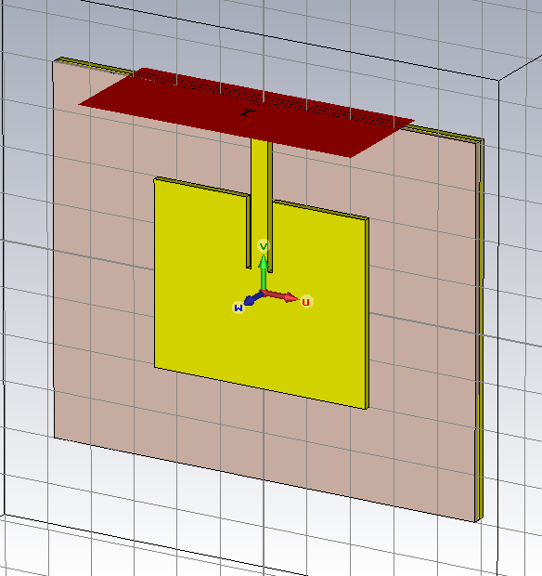
Figure 1. Rectangular patch parameterization (Top) and software model for rectangular patch (Bottom).
Operating frequency, length and width can be calculated as:
$f_{0}= \frac{C}{2L\sqrt{є_{r} }}, (1)$

$W= \frac{1}{2f_{0}\sqrt{є_{0}µ_{0}}}\sqrt{\frac{2}{є_{r}+1}}=\frac{c}{2f_{0}}\sqrt{\frac{2}{є_{r}+1}}, (2)$
$L= \frac{1}{2f_{0}\sqrt{є_{reff}}\sqrt{є_{0}µ_{0}}}-2ΔL, (3)$
Where
$f_{0}$= the fundamental operating frequency in hertz
W = the patch width in meters
L= the patch length in meters
$є_{o}$= permittivity
$є_{r}$= substrate dielectric constant
$c$ = the speed of light in vacuum in m/s
The dimensions for the designed patch shown above in Figure 1 are further tabulated in Table I:
Triangular Patch: The triangular patch antenna is another type of MPA. It is used where there are size constraints because the triangular patch theoretically takes less space than its rectangular counterpart. The shape of the triangular patch is shown in Figure 2. Since it is an equilateral triangle and all the sides are same. The impedance matching cannot be achieved by changing A, because it would also change the operating frequency. Therefore, the inset feeding is the only way for this type of antenna to achieve impedance matching [7]. The calculation is as follows:
$f_{0}= \frac{2c}{3a\sqrt{є_{r}}}$ (4)
Where,
$f_{0}$= the fundamental operating frequency in hertz
A = the patch length in meters
$є_{r}$= substrate dielectric constant
$c$ = the speed of light in vacuum in m/s
Table 1.
Rectangular patch parametrization
Parameter | Description | Value
GL | Ground Plane Length | 92.9 mm
GW | Ground Plane Width | 48 mm
MT | Ground Plane Height | 1 mm
SUBSTRATE | Arlon Copper,$є_{r}$ | 2.2
h | Substrate Height | 1.60 mm
L | Patch Length | 40 mm
W | Patch Width | 48.6 mm
L1 | Inset Length | 15.5 mm
W1 | Inset Width | 6 mm
L2 | Feed Line Length | 22.45 mm
W2 | Feed Line Width | 4 mm

$f_{0}= \frac{2C}{3a\sqrt{є_{r} }}, (4)$ $f_{0}= \frac{2c}{3a\sqrt{є_{r}}}$
Where,
$f_{0}$= the fundamental operating frequency in hertz
A = the patch length in meters
$є_{r}$= substrate dielectric constant
$c$ = the speed of light in vacuum in m/s

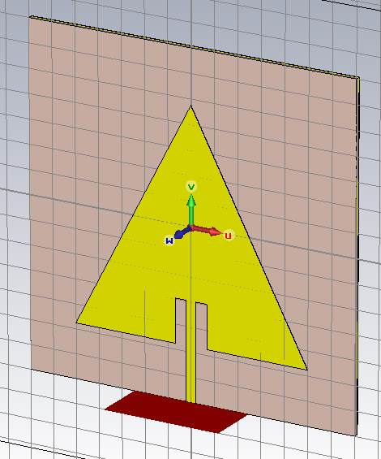
Figure 2. Triangular patch parameterization (Top) and software model for triangular patch (Bottom).
The dimensions for the designed patch shown in Figure 2 are tabulated below in Table II:
Table II
Rectangular Patch Parametrization
Parameter | Description | Value
GL | Ground Plane Length | 70 mm
GW | Ground Plane Width | 70 mm
MT | Ground Plane Height | 0.1 mm
SUBSTRATE | Arlon Copper, $є_{r}$ | 2.2
h | Substrate Height | 1 mm
A | Side Length | 50 mm
L1 | Inset Length | 9 mm
W1 | Inset Width | 6.82 mm
L2 | Feed Line Length | 40.7723 mm
W2 | Feed Line Width | 2 mm
Findings: Design and dimensions of both rectangular and triangular patch antenna are shown in the tables above, with substrate $є_{r}$=2.2 and height 1mm. It is clearly shown in Figure 3 that both designs are approximately resonating at 2.4GHz. The reflection coefficient $S_{11}$for both rectangular and triangular geometries is -36dB and -32dB respectively.
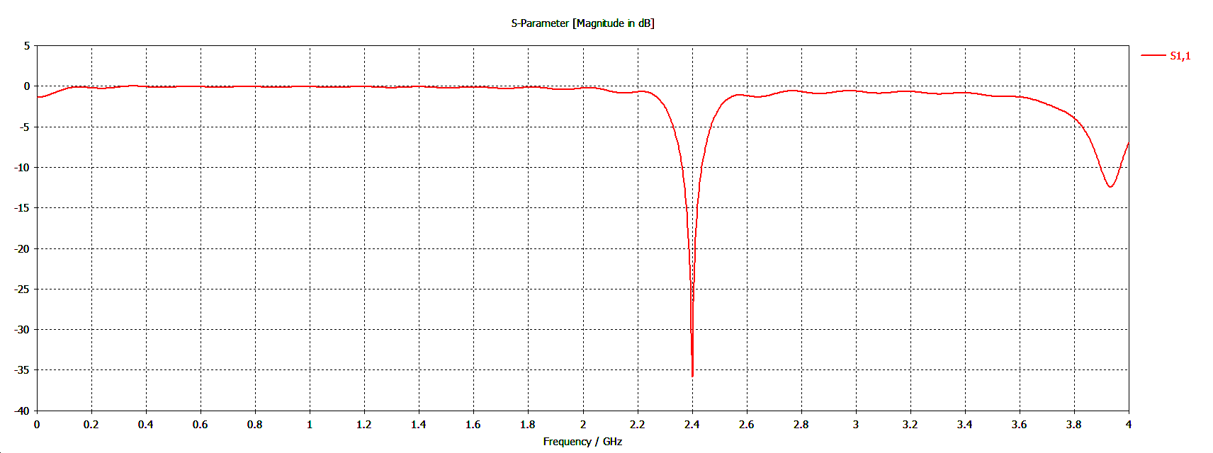 (a)
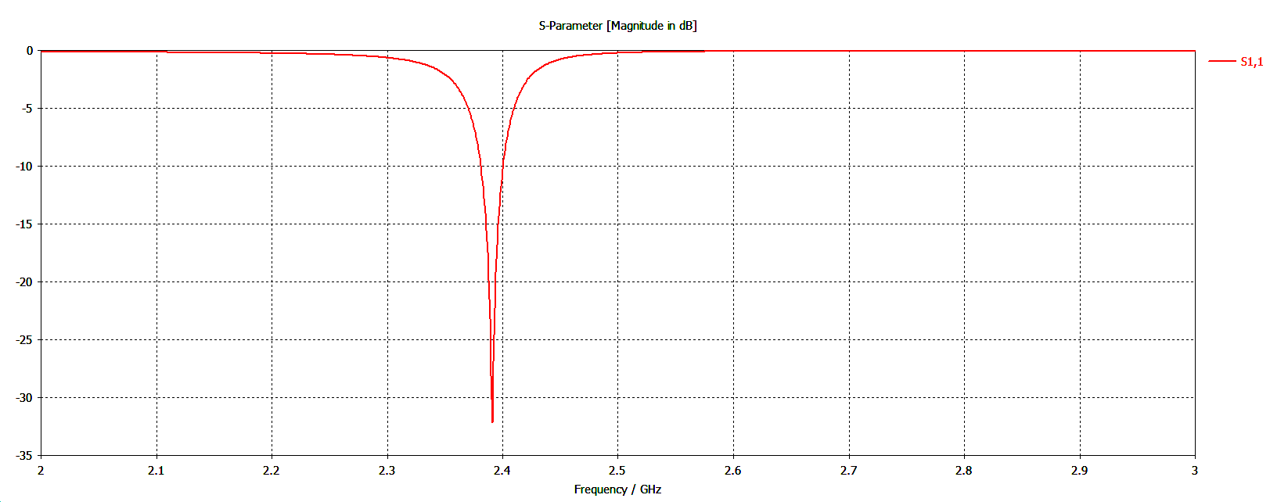
(b)
Figure 3. Reflection coefficient $S_{11}$ parameter (a) Rectangular Patch (b) Triangular Patch.
The radiation patterns of both geometries are also shown in Figure 4(a) and 4(b). The Gain values for rectangular and triangular patterns are 4.348dB & 6.082dB. The directivity for both geometries shows values 7.96dBi & 6.9dBi. Both gain and directivity of triangular patch depicts better performance than rectangular.
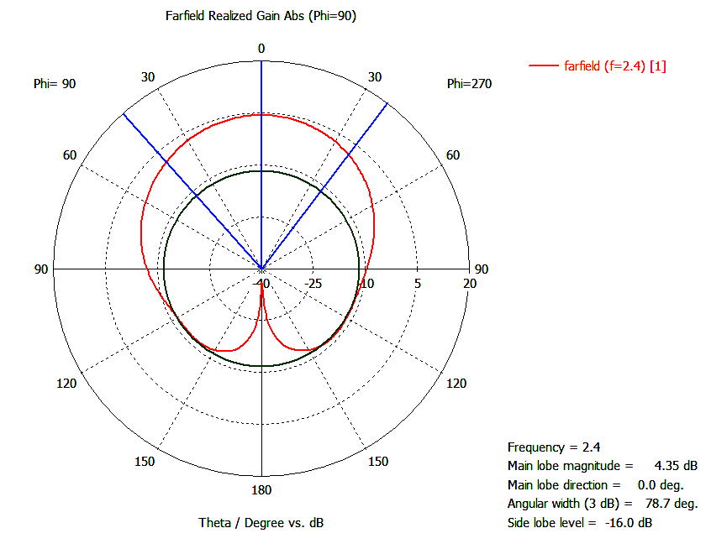
a (Rectangular)
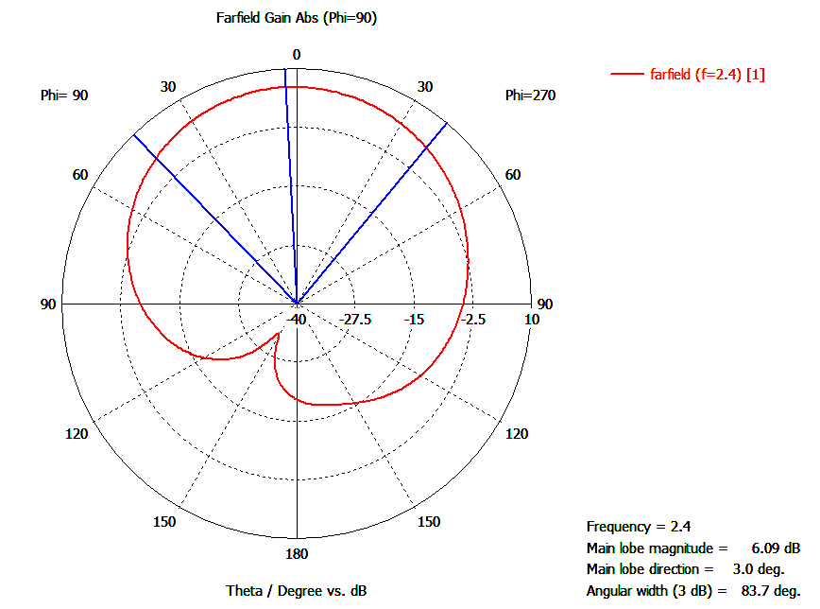
a (Triangular)
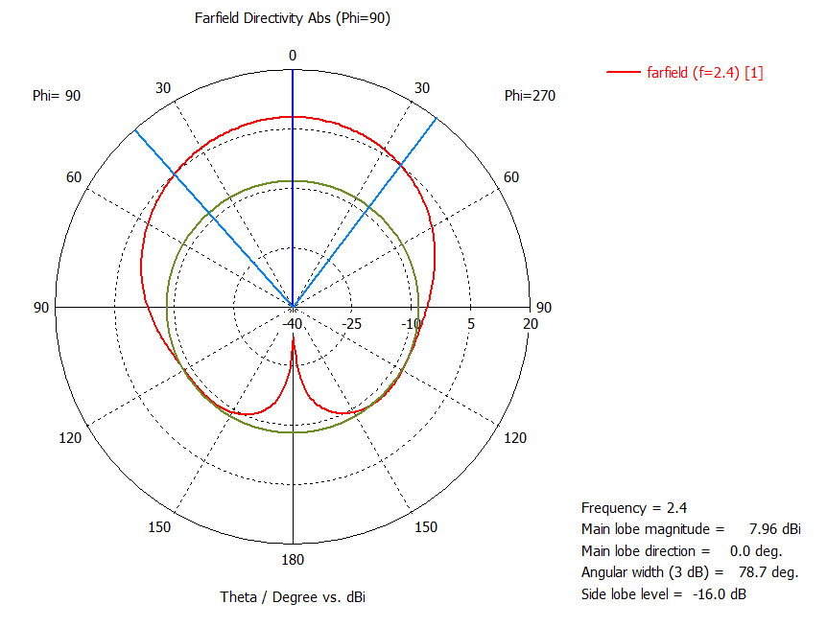
b (Rectangular)
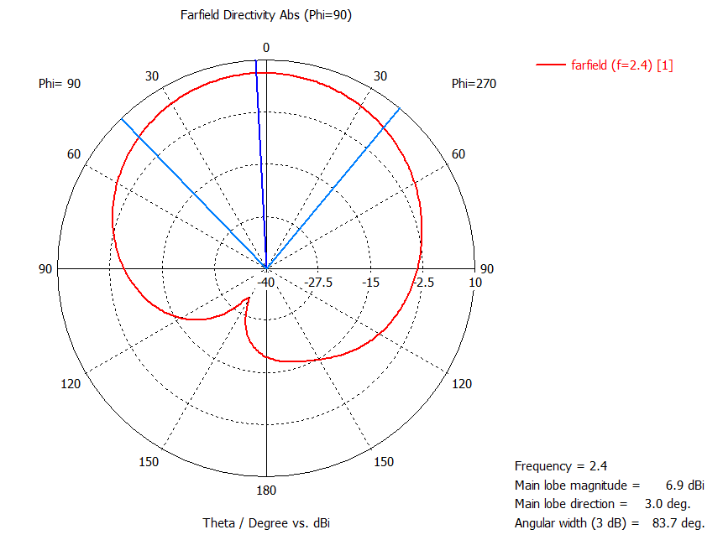
b (Triangular)
Figure 4. Rectangular and triangular patch far field radiation pattern (a) Gain (b) Directivity.
ARRAY DESIGN: MPAs can be used as a single element as well as arranging of elements in linear or volumetric manner called arrays. MPA arrays are usually used for the enhancement of gain, directivity, bandwidth, beam scanning and steering capabilities. A linear array is discussed in this paper. In that array elements are placed at certain distance and microstrip line feeding method is implemented for being easily fabricated and modeled as an extension of patch.
2×1 Array: All the dimensions for length of inset feed, patch thickness, patch length, area, substrate and height for 2x1 array is same as that of a single patch element. The other patch which is contributing for making an array is the replica of single patch whose dimensions are calculated in Table I and Table II. The distance between the two patches is 96mm. To obtain 50Ω impedance the line was split into two sections of 100Ω with widths W3 and W4 for both geometries. The parameters and simulated results of both designs are shown below in Figure 5(a) and 5(b).
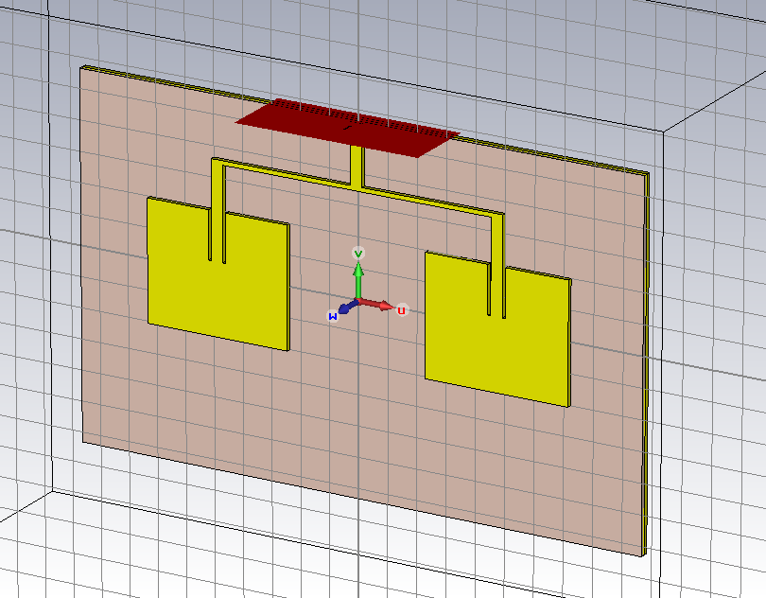
(a)
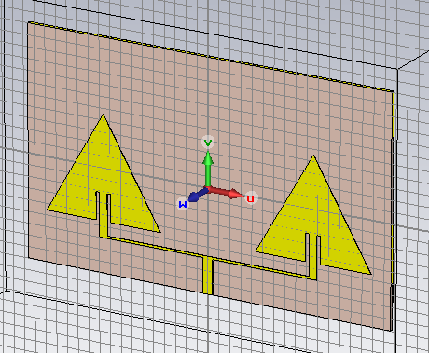
(b)
Figure 5. 2×1 Array parameterization and software model (a) Rectangular (with L2 = 30 mm, L3 = 96 mm, L4 = 15 mm, W3 = 1.41 mm, W4 = 4 mm) (b) Triangular (with L2 = 18 mm, L3 = 96 mm, L4 = 15 mm, W3 = 1 mm, W4 = 4.4454 mm).
Figure 6(a) and (b) show the reflection coefficient for both configurations. It further shows that the antennas are approximately resonating at 2.4GHz with a return loss of -37.5dB and -42.5dB respectively.
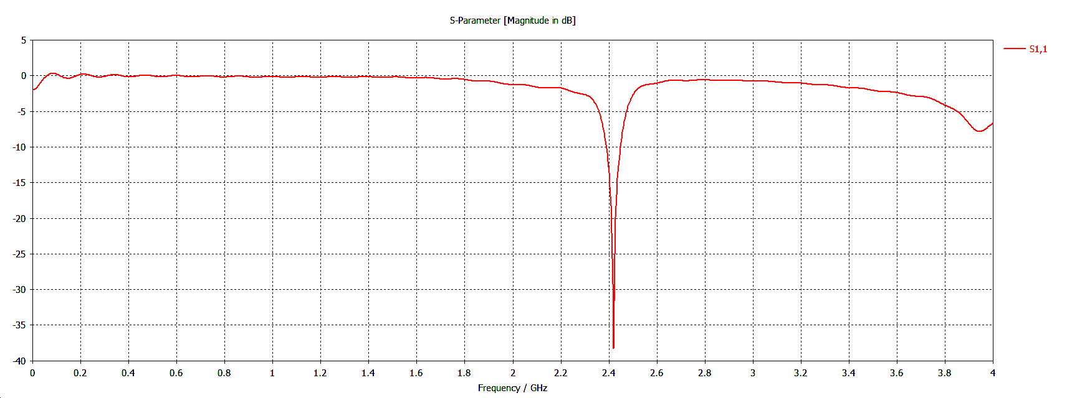
(a)
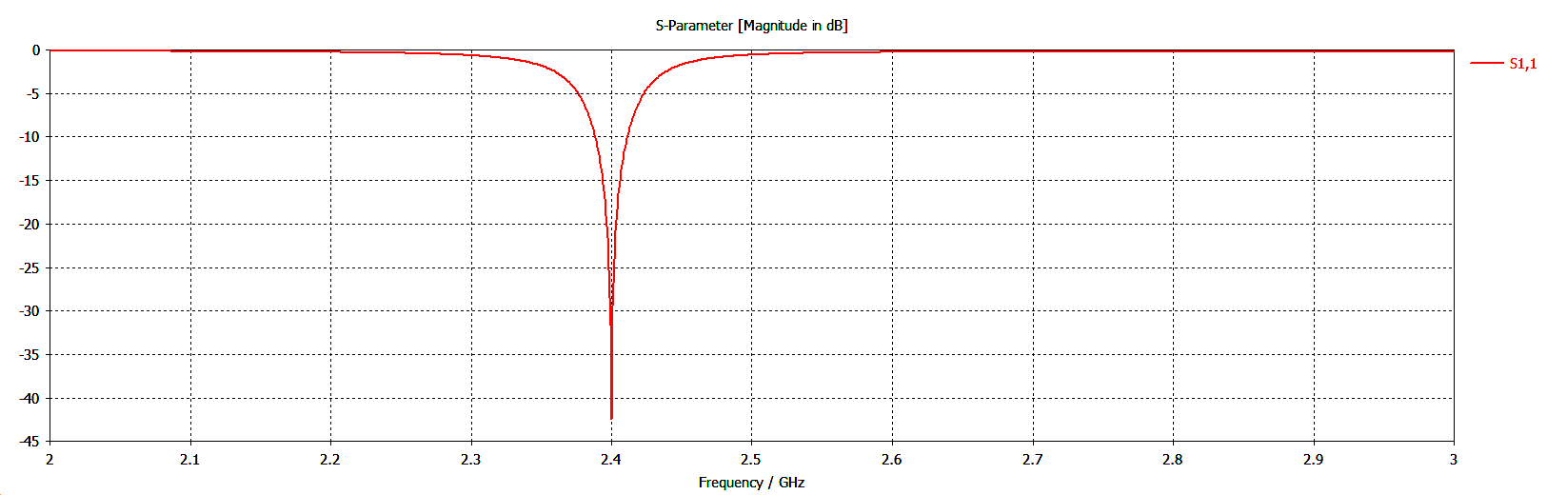
(b)
Figure 6. 2×1 Array reflection coefficient (a) Rectangular array (b) Triangular array.
The gain and the directivity of the microstrip patch increases due to the constructive interference of the electromagnetic fields of the two patches. The values obtained are almost double the values for a single patch i.e. 8.62dB & 11.3dBi for rectangle and 10.4dB & 10.9dBi for triangle as shown in Figure7 (a) and (b). The radiation pattern for the 2×1 arrays formed side lobes for gain and directivity as well as a major lobe. The main lobe is significantly stronger than the other two lobes which is directed perpendicular to the plane of the patch geometry at an angle of 69.9 and 72.9 degrees for the half power beam-width.
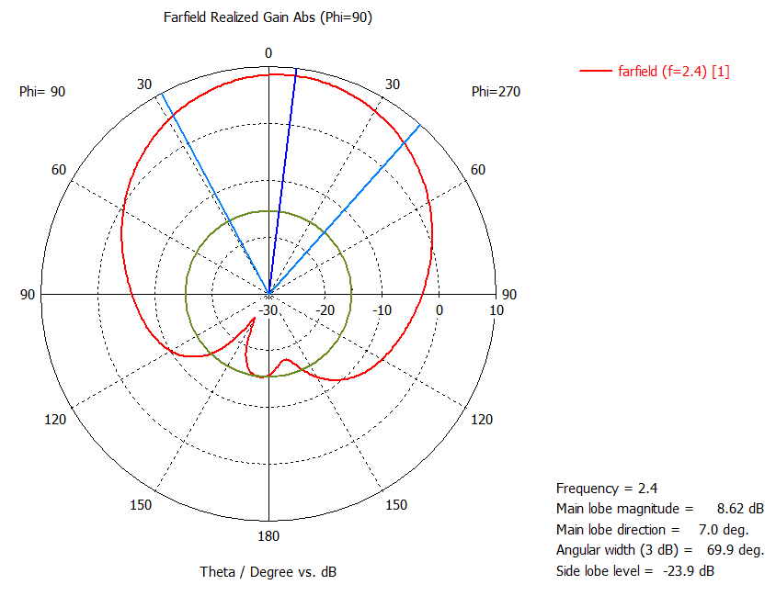 a (Rectangular)
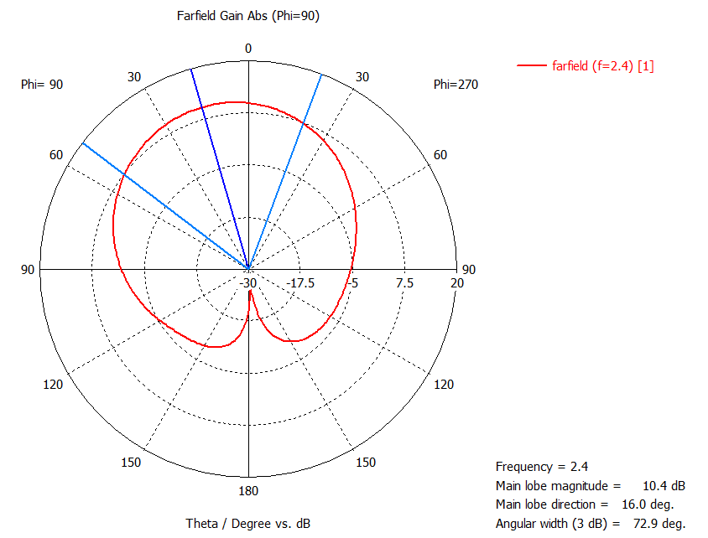 a (Triangular)
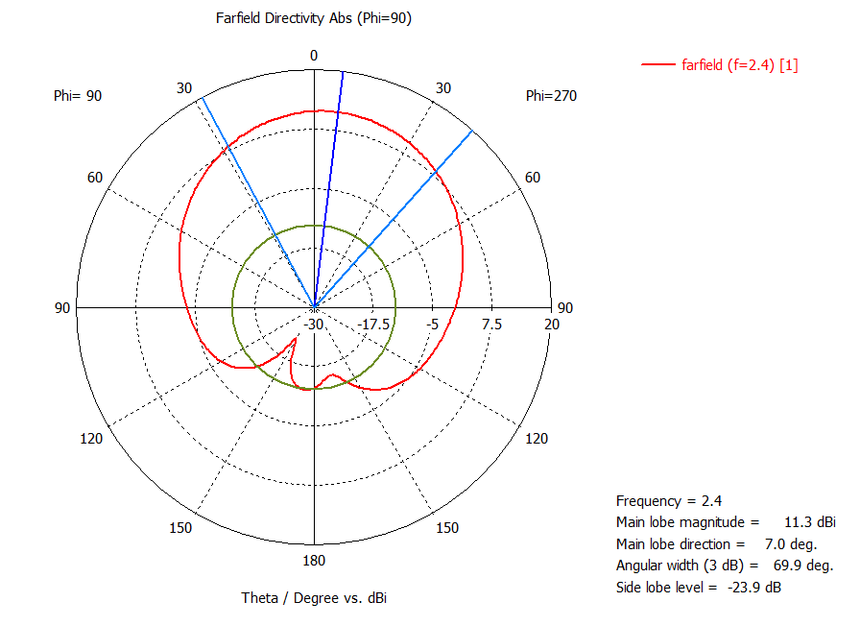
b (Rectangular)
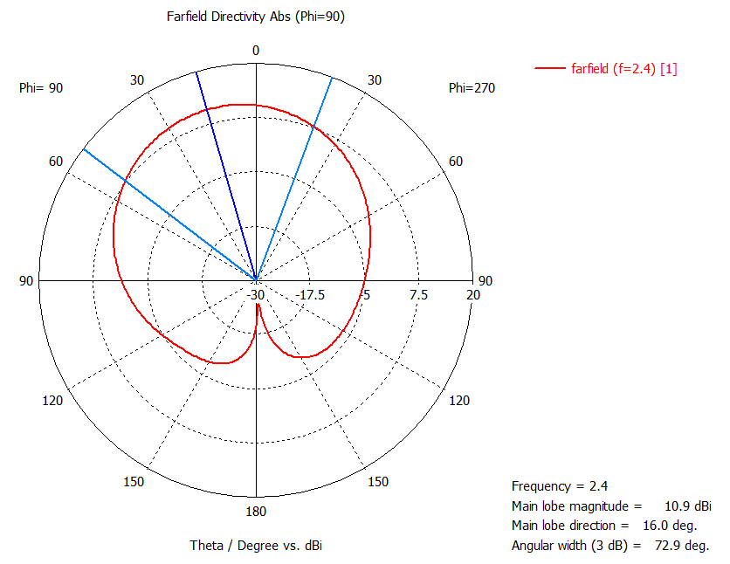
b (Triangular)
Figure 7. 2×1 Rectangular array far-field radiation pattern (a) Gain (b) Directivity.
4×1 Array: Figure 8 shows the parameters and simulated results of 4×1 array for further improvement of the gain and directivity of the patch antenna array. The two microstrip patches are connected with another pair of microstrip patch to make 4×1 array. This increases the complexity of impedance matching even further. A 50Ω network is designed so as to achieve minimum mismatch between the antenna port and the feed network with width dimensions as shown in Figure 8.
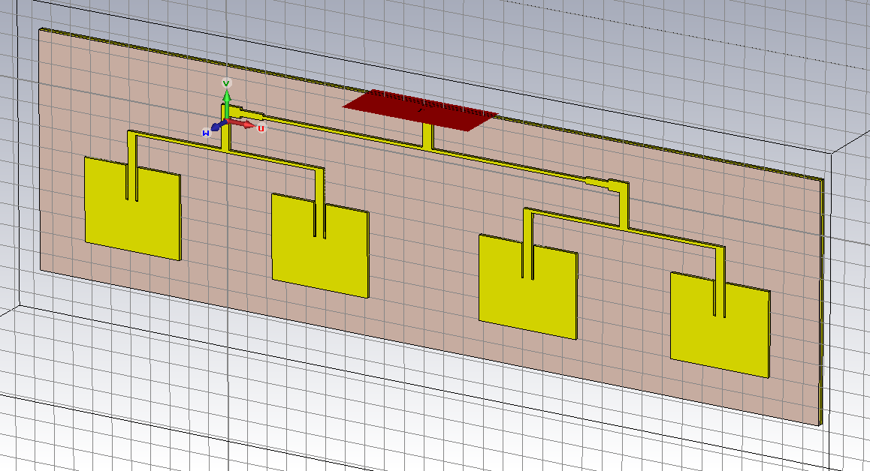
(a)
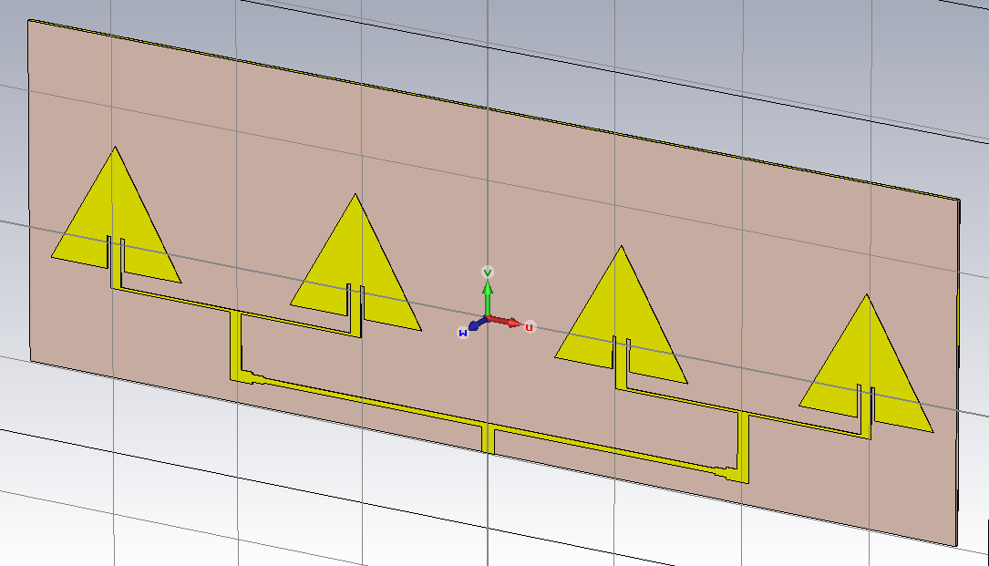
(b)
Figure 8. 4×1 Array parameterization and software model (a) Rectangular (with L5 = 201.2 mm, L6 = 9.78 mm, L7 = 23.1 mm, L8 = 19.4475 mm, W5 = 1.41 mm, W6 = 4.89 mm, W7 = 2.85 mm, W8 = 4.89 mm) (b) Triangular Array (with L5 = 201.2 mm, L6 = 9.78 mm, L7 = 23.1 mm, L8 = 19.4475 mm, W5 = 1.41 mm, W6 = 4 mm, W7 = 4.89 mm, W8 = 4.3084 mm).
The results for the reflection coefficient S11 parameter for triangular and rectangular geometries are -28dB & -17dB respectively and are shown in Figure 9.
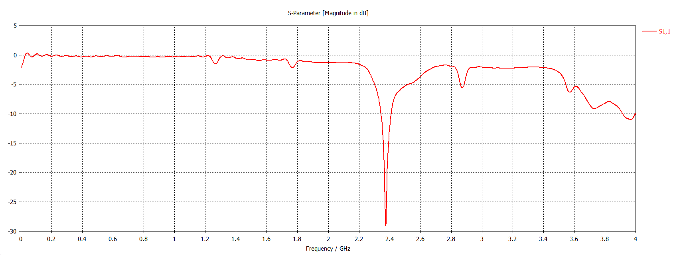 (a)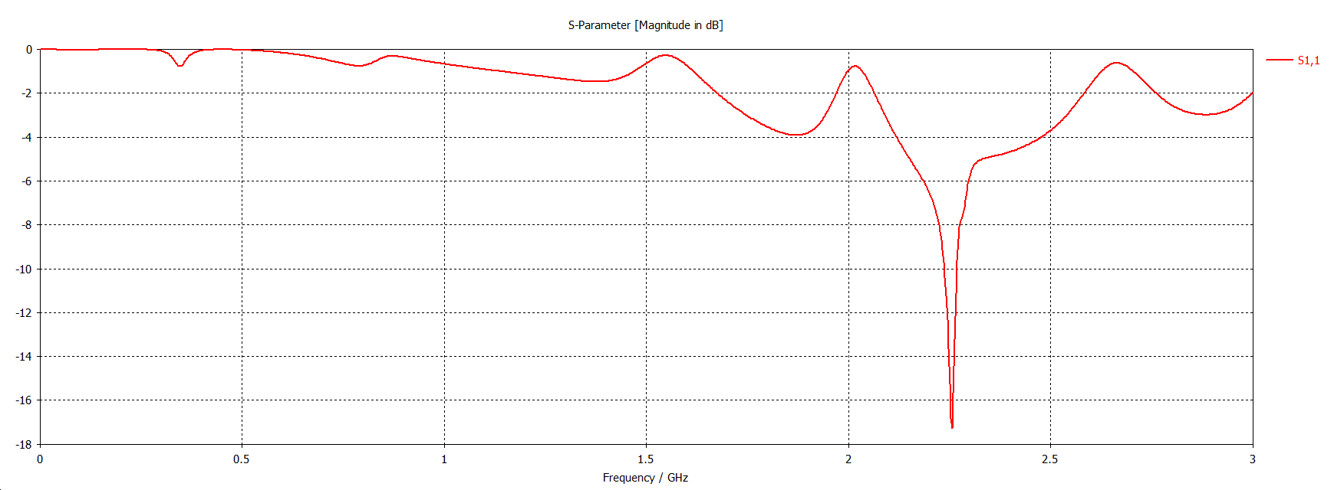 (b)
Figure 9. 4×1 Array reflection coefficient. (a) Rectangular (b) Triangular.
The gain and directivity further increases in Figure10 and the values obtained are almost three times the values of a single patch i.e. 10.9dB & 13.5dBi for the rectangular array and 12.3dB & 13.6dBi for the triangular array.
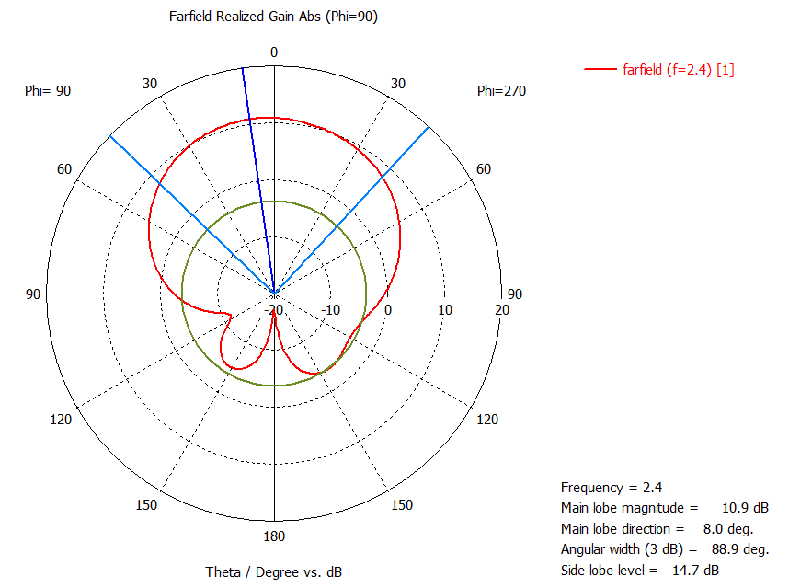
a (Rectangular)
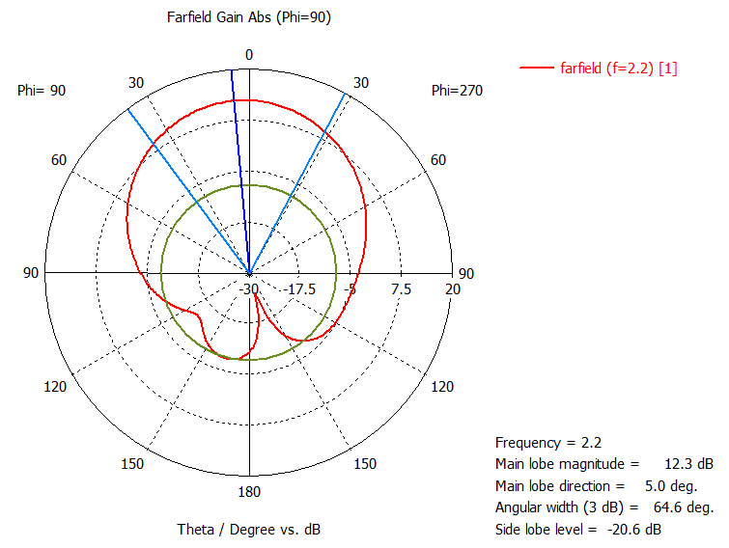
a (Triangular)
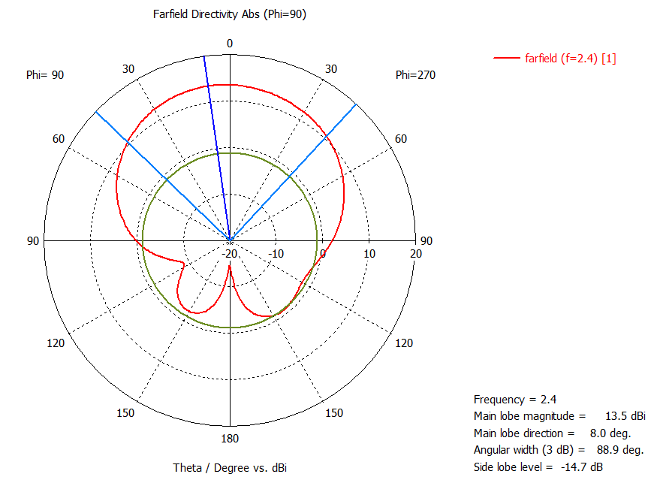 b (Rectangular)

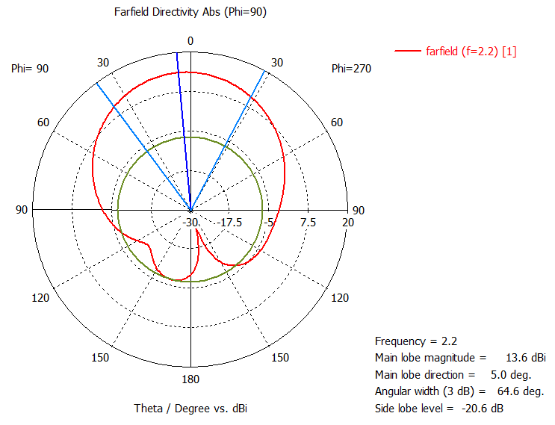
b (Triangular)
Figure 10. 4×1 Array far-field radiation pattern (a) Gain (b) Directivity.
The radiation pattern for the 4×1 array formed two side lobes on each side of the antenna, one for gain and directivity and another dominant major lobe. The main lobe is directed perpendicular to the plane of the patch geometry at an angle of 88.9 and 64.6 degrees for the half power beam-width for both geometries.
- SIMULATION RESULTS
Summary of the results obtained from the simulations is tabulated below in Table III. Table III describes the comparison between the different geometrical designs. Enhancement in gain and directivity was seen in both geometries. The $S_{11}$ parameter which is basically reflection coefficient is the measure of mismatch between the antenna port and the transmission line whose value should be below -10dB. Table shows its best value in 2x1 array of triangular geometry. Overall the triangular patch is superior as compared to the rectangular patch for all three cases and showed better performance for the enhancement of gain and directivity. Furthermore, triangular patch occupies less area (1250 mm²) as compared to that of rectangular (1944 mm²). From the side lobe suppression results, it is observed to be superior in the triangular patch as compared to rectangular patch. This makes it suitable for radar applications where side lobes may cause false target detection.
The designed antenna is highly suitable for wireless body area network (WBAN) applications, such as wearable gadgets compatible with industrial scientific & medical (ISM) bands [8, 9, 10]. Since the back lobe in this case is precisely underdeveloped as compared to the main lobe, this helps in decreasing the amount of radiation towards the contact surface of the wearable device.
Table III
Simulation Results
No. of Elements | $S_{11}$(dB) |  | Gain (dB) |  | Directivity (dBi)
 | Tri | Rect | Tri | Rect | Tri | Rect
Single | -32 | -36 | 6.09 | 4.35 | 6.89 | 7.96
2×1 | -42.5 | -37 | 10.40 | 8.62 | 10.8 | 11.3
4×1 | -17.3 | -29 | 12.30 | 10.90 | 13.6 | 13.5

- CONCLUSION
In this paper, a single element as well as arrays have been implemented and compared for triangular and rectangular geometries using CST microwave studio. Simulation results using array technique proved that the antenna resonate at 2.4GHz with dielectric constant $є_{r}$=2.2, enhancement of directivity up to 13.5dBi and gain 10.90dB. Furthermore, this design is capable to operate for any 2.4 GHz WLAN application, such as Wi-Fi (IEEE 802.11), ZigBee (IEEE 802.15.4) and other hobby radio applications. The designed antenna patches could also be implemented for the 2.4 GHz section of the Wi-Fi specifications e.g. 806.11ac. Since this frequency falls under the ISM band, various biomedical applications are also functional in this frequency range.

- REFERENCES
- M. T. I. Huque, et al., "Design and Simulation of a Low-cost and High Gain Micro strip Patch Antenna Arrays for the X-band Applications," International Conference on Network Communication and Computer –ICNCC 2011, New Delhi, India., pp 21-23,March 2011.
- C. A. Balanis “Antenna Theory: Analysis and Design”, 3rd ed. United States: Wiley Interscience, 2005.
- A. S. Mekki, M. N. Hamidon, I. Alyani, A. R. H Alwahari, “Gain enhancement of a microstrip patch anteanna using a reflecting layer”, International Journal of Antennas & Propagation., Vol. 2015, pp 1-7. 7, January 1, 2015.
- B. B. Qas Elias, M. Hussein, “Microstrip patch antenna performance improvement for 2.45GHz applications”, International journal of research in computer applications and robotics, Vol.3 Issue.1, pp 33-43, January 2015.
- A. M. Affandi , A. M. Dobaie, N. Kasim, N. A. Al-Zahrani, “Rectangular Microstrip Patch Antenna Arrays With Inset for Cellular Phones Application”, Journal of Electronic Systems. Vol 5, Number 1, March 2015.
- T. Sowjanya, M. Kishore Kumar, Dr. E. Kusuma Kumari, “Design of rectangular patch antenna array for wireless communications”, IJESR, Vol-5 Issue.11, pp 1420-1427, November 2015.
- Y. S. H. Khraisat, M. M. Olaimat and S. N. Abdel-Razeq, “Comparison between Rectangular and Triangular Patch Antennas Arrays”, Applied Physics Research, Vol. 4, No. 2, 2012.
- I. Singh, Dr. V.S. Tripathi, “Micro strip Patch Antenna and its Applications: a Survey, IJCTA, Vol. 2 (5), pp.1595-1599, 2011.
- R.J. Chitra, A. Suganya, V. Nagarajan, “Enhanced gain of double U-slot microstrip patch antenna array for WiMAX application” IEEE International Conference on communication and signal processing, Chennai, pp. 141-144, 2012.
- N. Sharma, B. Jain, P. Singla, R. R. Prasad, “Rectangular patch microstrip antenna: A survey”, International Advanced Research Journal in Science, Engineering and Technology, Vol. 1, Issue 3, pp. 144-147,November 2014.

