VIOLENCE AGAINST WOMEN:
A CASE STUDY OF KIDNAPPING IN THE PUNJAB, PAKISTAN.
Imran Siddique Kaukab¹ and Tabasam Jamal Shad²
¹Deputy Registrar, University of the Punjab, Lahore.
²Professor, Geography Department, University of the Punjab, Lahore.
Corresponding Author: Imran Siddique Kaukab: drhr.admin@pu.edu.pk
ABSTRACT: : This research focuses the violence of women kidnapping in the Punjab province of Pakistan. Kidnapping record is lofty in specific areas due to the existence of media, education, awareness of law and personal rights. Through analysis, it is found that violence is increasing 1.02 to 1.19% per year. The reasons behind this can be numerous, but day by day progression, frequent involvement of women in street and professional life, violence seen on media and movies is seemed to be providing supporting tools for violence in spite of its prevention. While in the areas where these factors are less, Women kidnapping is very rare like in the tribal areas.
Key words: Kidnapping, crime, violence, women

INTRODUCTION:
The crime of unlawfully seizing and carrying away a person by force or fraud against her will is called kidnapping. Unlawful arrest and imprisonment of any women for any purpose is called kidnapping violence. Kidnapping is an offence at common law. (A Law Dictionary, Adapted to the Constitution and Laws of the United States. By John Bouvier, 1856). The United Nations General Assembly (UNGA), in its resolution on the Declaration on the Elimination of Violence Against Women, defines "violence against women" as "any act of gender-based violence that results in, or is likely to result in, physical, sexual or mental harm or suffering to women, including threats of such acts, coercion or arbitrary deprivation of liberty, whether occurring in public or in private life. Now a day’s kidnapping is occurred for many purposes. The men belong to elite families abduct the women for the sexual satisfaction. The professional criminals persons kidnapped the women for the money. Some women are kidnapped for property by the family member or other person and they force the women to give them the property. Some political leaders kidnapped the women of opposite party by their men to pressurized them to knee down before them. Some women are kidnapped by the lover or other landlord and power full person to force down the women to marry them this is called forceful marriage. Kidnapping is high in the central and south eastern part of the Punjab province while the south western and north eastern part of the Punjab have low kidnapping rate during 2001 to 2010. Where there is media access is strong there is high kidnapping because media high lights the cases although kidnapping is such phenomena which is occurring in the Punjab under the same rate but cannot come on the scene due to absence of media. In that area where the people are educator, they are aware about the law they go to court and fight for their rights. It is astonishing fact that with the passage of time Pakistani society is developing due to more education, better situation in law and order but kidnapping violence is increasing gradually. Commonly all crimes are developed according to motives whenever motives cannot be closed under a specific confines. Due to advance and modern means of transportations, easily availability of cell phones, strong and true information about the target and deference techniques which are coming from the media and other criminal activities through the movies are such tools which helps kidnapper’s task. To control kidnapping it is essential to establish good policy, proper protection system, best situation of law and order and their ultimate application can be prevent the kidnapping in the Punjab.

MATERIAL AND METHOD:
This research was conducted in the Punjab province which is the most populated province of Pakistan. The present research is based on historical method for tracing primary and secondary sources of information. Survey method has also been used to collect the personal observational data. It covers the kidnapping violence against women being made in the province of Punjab. The research covers the period from 2001 to 2010. The data regarding reported cases of kidnapping violence against women was collected from the sources as like a monthly magazine “Jiddo Juhad”, issued by the Human Rights Commission of Pakistan and its Yearly reports from 2001 to 2010. Data was also gathered from the News clippings and Shirkat Gah, (Women Research Centre). Reports issued by Aurat Foundation were also consulted. The data kept at the Punjab Criminal Record Office was also browsed and properly put in the form for this purpose. The form shows the kidnapping violence against women committed in each districts of the Punjab within a year. Data thus collected was processed through cartographic techniques, statistical methods and GIS software. The maps were prepared for the purpose of visualization and analysis, to achieve the objective of the study with the help of the analysis done. The conclusions are drawn. Recommendations are put forward for decision cum policy make NGOS and government functionaries for minimization of violence against women.

RESULTS AND DISCUSSION:
This section explains an evaluation of present research on women’s kidnapping violence in the Punjab province which has been occurred during the period of 2001 to 2010. The data was gathered through the different sources from all the 36 districts of the province of the Punjab. The following table is showing the kidnapping in all 36 districts during the period of 2001 to 2010. According to the table the number of kidnapping in Lahore, Kasure, Sheikhupura, Nankana Sahib, Faisalabad, Jhang, Sargodha, Chakwal, Rawalpindi, Sialkot and Multan have seen maximum. It is due to advancement in media, awareness of law education, awareness of personal rights and access to the strong social lobbies. In second place, come Okara and Vehari, where number of recorded events are from 201 to 250. In third place, comes Gujrat where numbers of cases are from 151 to 200. In Gujrawala, Mandi Bahduddin, Toba Tek Singh, Sahiwal, Muzaffergarh and Lodhran the total numbers of reported cases of kidnapping of women are from 101 to 150. A fact should be kept in mind that many events of kidnapping remained unrecorded because most people prefer not to contact law enforcing agencies. As far areas and people living in those areas does not have any easy access to latest technologies of communication. Therefore, many events remain unnoticed. This is the reason that Khushab, Bhakar, Layyah, Bahawalpur, Bahawalnagar, Rahim Yar Khan and Dera Ghazi Khan have the total number of recorded events only up to 50. Abduction/Kidnapping of Women in 2000-2010 is given in Table 1 and shown as a pie chart in Fig 2

.

Table 1: Abduction/Kidnapping of Women in 2000-2010

Sr. No. | District Name | 2001 | 2002 | 2003 | 2004 | 2005 | 2006 | 2007 | 2008 | 2009 | 2010 | Grand  Total
1 | Attock | 2 | - | 1 | 3 | 7 | 1 | 2 | 16 | 17 | 19 | 68
2 | Bahawalnagar | - | 2 | 3 | 4 | 1 | 3 | 1 | 2 | 4 | 6 | 26
3 | Bahawalpur | 1 | 3 | 4 | 1 | 4 | - | 4 | 3 | 1 | 1 | 22
4 | Bhakkar | 4 | 5 | 1 | 2 | - | 2 | 3 | 3 | 1 | 2 | 23
5 | Chiniot | 1 | - | 1 | - | 2 | 1 | - | 4 | 4 | 6 | 19
6 | Chakwal | 8 | 12 | 17 | 22 | 30 | 39 | 38 | 41 | 45 | 47 | 299
7 | D.G. Khan | 1 | 2 | 3 | 1 | 3 | 4 | 6 | 9 | 11 | 12 | 52
8 | Faisalabad | 79 | 109 | 124 | 157 | 192 | 201 | 190 | 261 | 265 | 272 | 1850
9 | Gujranwala | 1 | 2 | 1 | 2 | 7 | 19 | 25 | 26 | 28 | 32 | 143
10 | Gujrat | 8 | 12 | 15 | 17 | 21 | 23 | 25 | 27 | 28 | 29 | 205
11 | Hafizabad | 1 | 3 | 4 | 6 | 9 | 8 | 9 | 18 | 20 | 23 | 101
12 | Jhang | 21 | 30 | 32 | 49 | 55 | 49 | 41 | 29 | 31 | 30 | 367
13 | Jhelum | 8 | 3 | 4 | 1 | - | 1 | 3 | 5 | 3 | 3 | 31
14 | Kasur | 26 | 41 | 47 | 58 | 62 | 65 | 85 | 78 | 80 | 85 | 627
15 | Khanewal | 31 | 35 | 39 | 42 | 44 | 49 | 53 | 33 | 34 | 36 | 396
16 | Khushab | - | 2 | 3 | 4 | 6 | 7 | - | 9 | 11 | 12 | 54
17 | Lahore | 121 | 175 | 195 | 245 | 265 | 298 | 348 | 375 | 372 | 379 | 2773
18 | Layyah | 4 | 1 | 1 | 8 | 6 | 7 | 8 | 7 | 7 | 9 | 58
19 | Lodhran | 25 | 12 | 9 | 12 | 3 | 2 | 9 | 14 | 13 | 15 | 114
20 | Mandi Bahauddin | 6 | 8 | 12 | 17 | 15 | 17 | 8 | 9 | 10 | 11 | 113
21 | Mianwali | 4 | 3 | 4 | 3 | - | 1 | - | 1 | 1 | 1 | 18
22 | Multan | 22 | 18 | 31 | 45 | 38 | 39 | 55 | 59 | 64 | 69 | 440
23 | Muzaffargarh | 3 | 4 | 5 | 1 | 8 | 11 | 29 | 33 | 35 | 38 | 167
24 | Nankana Sahib | 25 | 31 | 39 | 49 | 55 | 59 | 35 | 32 | 39 | 41 | 405
25 | Narowal | 8 | 8 | 1 | 2 | 1 | 2 | - | 2 | 1 | 1 | 26
26 | Okara | 16 | 15 | 29 | 39 | 24 | 25 | 29 | 34 | 36 | 39 | 286
27 | Pakpattan | 4 | 2 | - | 1 | 2 | 3 | - | 6 | 8 | 9 | 35
28 | Rahimyar Khan | 3 | 4 | - | 7 | 5 | 6 | 9 | 4 | 5 | 7 | 50
29 | Rajanpur | 8 | 6 | 7 | 12 | 3 | 4 | - | 3 | 1 | 2 | 46
30 | Rawalpindi | 73 | 69 | 87 | 107 | 119 | 129 | 147 | 165 | 169 | 178 | 1243
31 | Sahiwal | 8 | 9 | 11 | 15 | 17 | 18 | 22 | 12 | 14 | 15 | 141
32 | Sargodha | 41 | 45 | 59 | 75 | 105 | 119 | 129 | 138 | 140 | 143 | 994
33 | Sheikhupura | 30 | 34 | 45 | 65 | 107 | 102 | 78 | 86 | 88 | 89 | 724
34 | Sialkot | 16 | 18 | 21 | 27 | 39 | 29 | 39 | 48 | 50 | 57 | 344
35 | Toba Tek Singh | 6 | 8 | 1 | 3 | 12 | 11 | 33 | 21 | 22 | 26 | 143
36 | Vehari | 5 | 7 | 12 | 18 | 31 | 36 | 46 | 38 | 40 | 43 | 276
 | Grand Total | 620 | 738 | 868 | 1120 | 1298 | 1390 | 1509 | 1651 | 1698 | 1787 | 12679
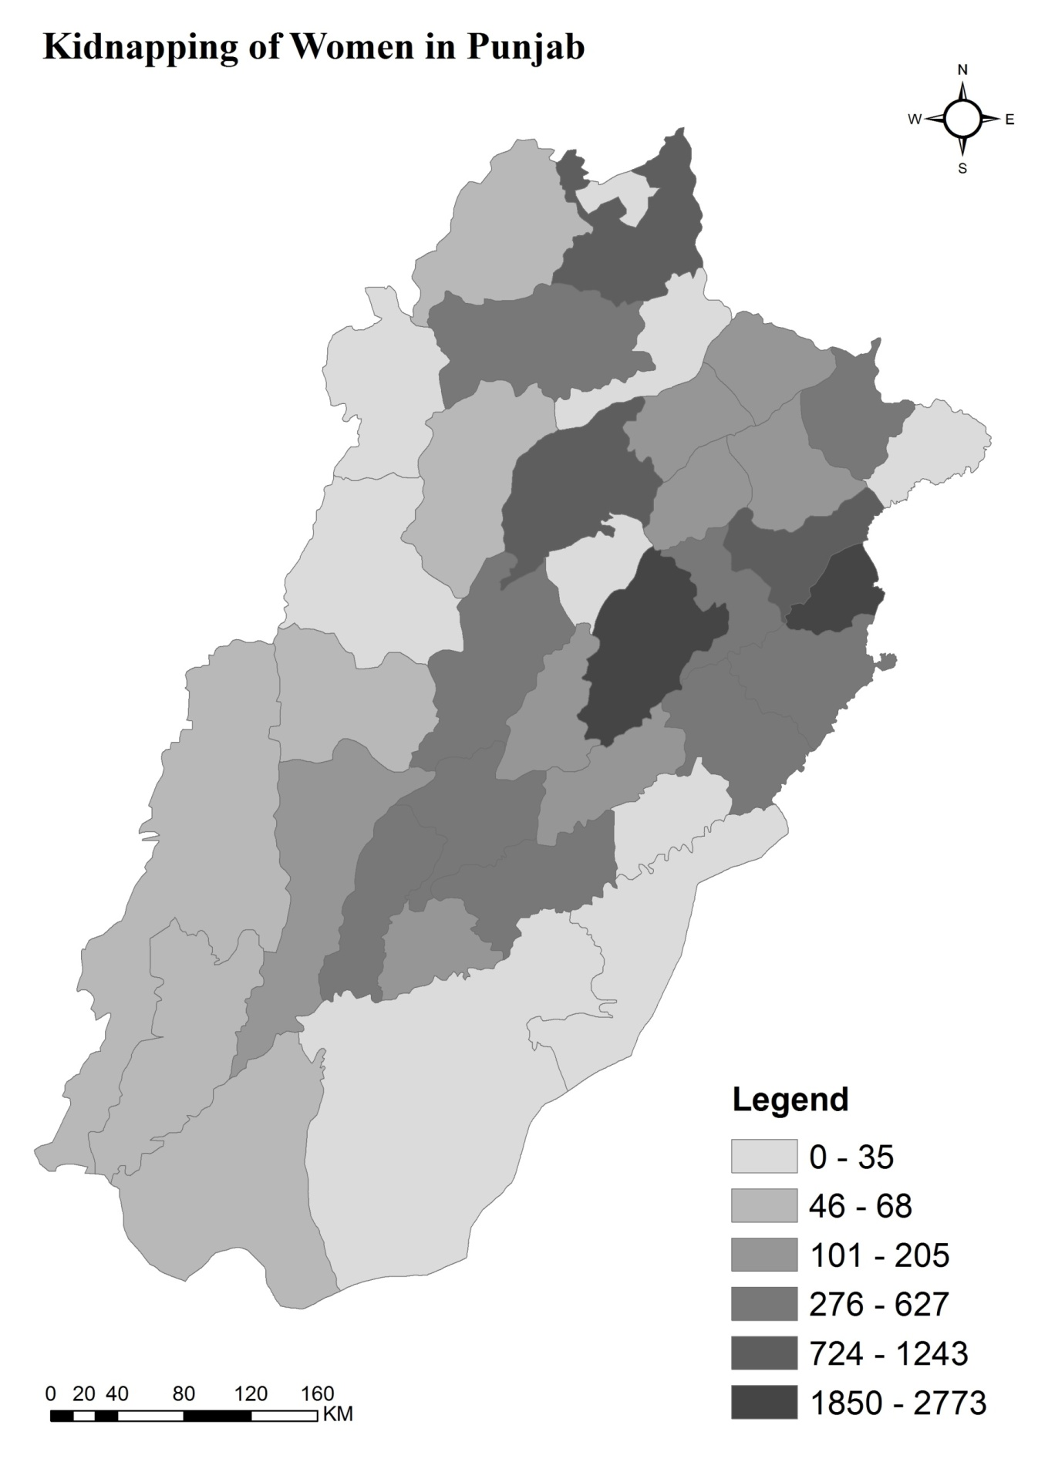
Fig 1 Map showing Kidnapping of Women in Punjab, Pakistan. (2001-2010)

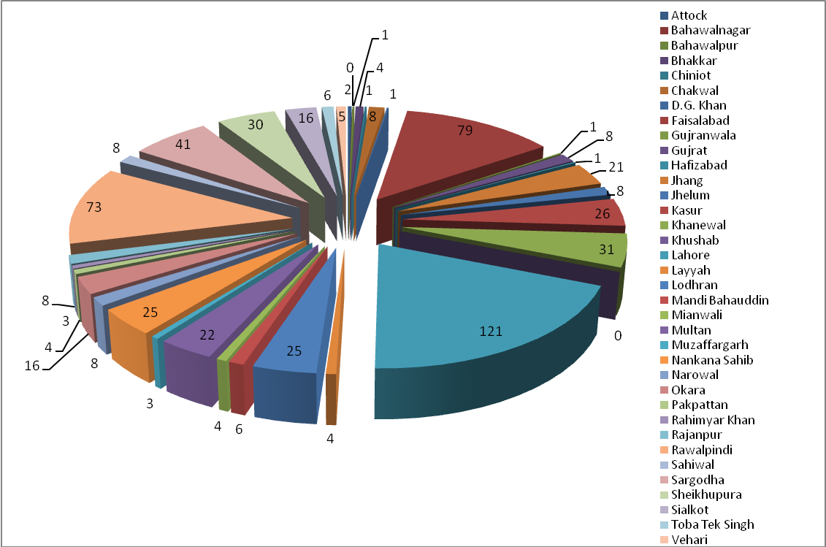
Fig 2 Pie Chart showing Kidnapping of Women in Punjab, Pakistan. (2001-2010)

CONCLUSION:
Kidnapping is such evil which is seen in high level during the 2001 to 2010 in all 36 districts of Punjab. Total number of kidnapping cases of women in the Punjab during the period of 2001 to 2010 were 12979. Women mostly were kidnapped for sexual purpose, getting the money, revenge for the honor, the political purposes, for the forceful marriage and for transformation of property. Central and south eastern part of the Punjab was seen high kidnapping due to presence of media, education and awareness about the law and personal rights. Even though Pakistani society is developing but kidnapping violence against the women is increasing instead of decreasing. Due to criminal movies, presence of cell phone and easy and quick information kidnapping is becoming the easy task for the kidnappers.
Suggestions:
Research Depicts Expansion in media and awareness can only be recognized the crimes but they can’t prevent the crimes. The government should have to make proper up dated and up graded planning against the criminals activities. Women Legal Supporting cells, vigorous protecting system for women should be established all over the Punjab. As well as sever punishments for kidnappers should be fixed.

REFERENCES:
- Sultana, A., Memoirs of a Rebel Princess. Oxford University Press, Karachi 2004.
- AGHS., Violence Against women in Pakistan, Legal Aid Cell, Lahore 2004.
- Syed, A. Pakistan, Islam, politics and national solidarity, Lahore 1984.
- Jahangir, A. and Jilani, H., The Hudood Ordinance: A divine sanction. Vanguard Books, Lahore, 1990.
- Ali, A. A., The emergence of feminism among Indian Muslim women from1930 to 194. Oxford University Press, Karachi, 2000.
- Awe, Bolanle. ed. Nigerian women in historical perspective. Sankore, Lagos, 1992.
- Bodman, H.L. and Tohidi, N., Women in Muslim Societies: Diversity within Unity. Baulder and co, England, 1998.

